An experience in seeing

Digital Divide Bridges Built in the US

A report submitted at the completion of
Eisenhower Exchange Program Single Regional Program 2002

Onno W. Purbo, Indonesia
Independent Information Technology Writer
onno@indo.net.id

September - November 2002

Content

Acknowledgements 2

For The Executives
Major Key findings 3
Experience gain in Eisenhower Fellowship 4
A Glimpse on My Efforts Prior To US Visit 5
Summary of Lesson Learned 7

For Those Who Likes Fine Details
Lesson Learned - In Policy & Regulatory Framework 8
Lesson Learned - In Grass Root Movements 10
Lesson Learned - In Alternative Technology Solutions 12

For Those of Interest
Youth The Agent of Change 13
Play While You Learn 14
Rural Telecommunication 15
Experienced in Helping 3rd World Countries 17
Community Tele Center 20
Professional IT Education for Colored Young Americans 23

Some Details
APPENDIX - List Of Organizations / Contact Persons Visited 25
Policy & Regulatory Framework 25
Grass Root Movements 28
Alternative Technological Solutions 32
APPENDIX – Some Web References 34

Acknowledgement

I’d like to specially thank Jennifer Pugh (jpugh@eisenhowerfellowships.org), my program officer, at Eisenhower Exchange Fellowship (EEF). Jennifer has put an excellent program that really helps me see the Americans in building their bridges in narrowing any digital divide in American rural, underserved and poor neighborhood.

I would also thank all of EEF board of directors, board of trustee, Ambassador Adrian Basora, and staff of EEF who really makes my US visit’ a fruitful and enjoyable one. Not to mention, the sponsors without whom the fellowship will not be possible.

Mas Ninok Leksono (’00) (ninok@kompas.com) at KOMPAS Jakarta, I owe you for nominating me into this exceptionally excellent EEF program. Bu Natalia Soebagjo (soebagjo@indosat.net.id), the chair of Indonesian EEF nominating committee.

I would like to thank all of my tutors in the US as listed in the appendix for generously sharing their precious time and expertise.

Major Key Findings

- Education! Education! Education! Education is the heart of transformation processes. It may create an aggregation demand in rural and underserved areas.

- Youth is the agent of change.

- Accountable leaders may catalysts transformation processes.

- Putting technology in place is the easiest part. Its social, politics, policy, cultural aspect that may create the unnecessary barrier. Build the usefulness of technology into the values of the culture would solve.

- “Fantasy of the Internet boom … customers would change their behavior on a schedule dictated by venture capitalists … reality is that - habits change much more slowly.” (David Coursey, ZDNet July 10th, 2001).

- “Basic problem of new technology, they don’t know what they don’t know. People don’t immediately recognize how to use “new” technology. Our task is to show and to teach them.” (R. Terry McGhee, RTC 2002).

- Demand-created supply scheme works best as compared to supply-created demand. It is an art in itself like chicken and egg, which comes first?

- Regulation is not God’s law. Regulation can affect but cannot create a demand nor a market. Mistakes in regulation can be disastrous (Richard Vohs, RTC 2002).

Some Interesting Practical Tactical Actions

- Community helps communities for higher multiplier effect.

- Privatization and competition may create the needed constructive environment. Balanced by empowering and funding rural and underserved communities’ infrastructure is essential.

- Network of small independent telephone companies and cooperative much more suitable and agile in adapting technology, providing advance services for rural and underserved areas.

- Multiple path knowledge delivery, e.g. CD-ROM, Harddisk based digital library, would be critical in providing knowledge to 3rd world country.

Experience gain in Eisenhower Fellowship

“The question is not what you look at, but what you see”
Hendry David Thoreau

Prior to the fellowship, I always thought I know America through papers, articles, and news available electronically on the Web. I have to admit that my prior knowledge is a narrowly partial picture. Eye to eye contact, direct interaction with many Americans, or even observing a debate among Americans, shows a significantly different overall picture.

Overwhelming information and knowledge acquire in the fellowships, it enhances significantly my point of view on America. Having focus on rural and underserved Americans, it yields many genuine best practices in building the bridges to narrowing the digital divide. The prior vague path becomes much more clearer as interaction goes. I found many best practices learned in rural and underserved America are very much in line with potential solutions needed in Indonesia.

Traditionally, education processes are used as the mean to realize my vision,

"To see the survival of Indonesians rely on their Brain rather than Muscles"

As shown in the lessons learned section, the experience gain will likely to significantly change the path of my contribution to Indonesian people. However, I really cross my finger for not cutting someone’s throat in the transformation processes.

Well …

“Life is like driving a car at night. You can only see a few dozen feet ahead – as far as the headlights. But you can make the whole trip that way.”
Richard Vohs, CEO Iowa Network Services

A Glimpse on My Efforts Prior To US Visit

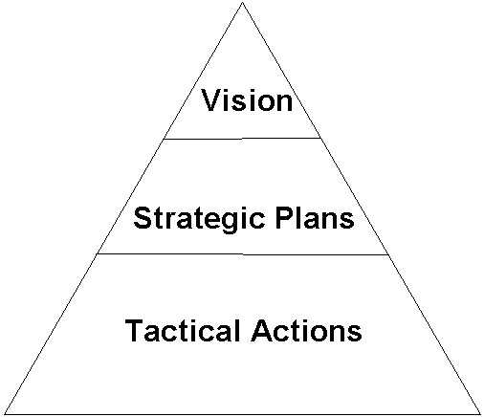
Most of my efforts prior to US visit can be easily described and structured as seen in the figure. All of the efforts are significantly driven by a simple vision, i.e.,

“To see the survival of Indonesians rely on their Brain rather than Muscles”

Basically, to see an Indonesian knowledge-based society is my ultimate dream. Unfortunately, having only ~1% of the population are on the Internet, and ~2% of the population with higher degree of education makes it a challenging task to be completed.

As I used to be a lecturer at the university, educating the Indonesian people is the conventional strategy used to reach the goal.

In reality, the tactical actions would have to be somewhat calibrated as I am working as an individual and not in a large organization. Several examples of workable tactical actions being used in my normal daily life are:

- Electronically interacts with people & creates network. Networking & having lots of friends are the substantial element to be able to efficiently perform at much lower cost.
- Use all media for publication in educating the Indonesians, such as, using CD-ROM, articles in magazines, publishing books, papers in journals, putting electronic versions on the Web, e.g., http://www.bogor.net/idkf/, etc.
- Do appear physically in seminars, workshops, and talk shows. In many instances, people will be more likely convinced after hearing & seeing physical appearances.

In short, all of the processes can be drafted as a circle of knowledge on my side. Fortunately, as more and more people interact electronically, we will likely to see an amazingly high speed of knowledge circulation and, in turn, a much shorter time creation of knowledge-based society in Indonesia.

I understand that having people’s education as my main strategic approach would not be enough to pursue any vision and goals. The objectives of my US visits, would be:

- To hear / see policy and regulatory framework specially in building the bridges in narrowing the digital divide.
- To hear / see any grass root movements, to see real example in the fields.
- Off course any alternative technology solutions that might help in narrowing the digital divide more effectively and low cost would always be welcome.

By doing so, I am hoping to gain several alternative strategic paths to pursue the goal and vision.

Summary of Lesson Learned

Philosophical foundation,

- Right of communication and access to information should be the foundation in transforming the society towards knowledge-based society.

Some of the main points learned in strategic level, namely,

- Education processes are the key in injecting any cultural changes to reshape the future. The building of school network would be the most strategic thing to do.
- Youth is the strategic agent of change, do educate the youth and they’ll change the future, the society as well as the culture.
- Education and awareness processes will in turn create demand and market. Aggregation demand would be the foundation of growth.
- Accountability, transparency & good governance would be crucial in the process.
- Accountable government leaders, community leaders and religious leaders may be an effective agent of change within society specially in narrowing digital divide.
- Mutual networking among stakeholders, non-profit organizations, business sector as well as government would play an important role.

Some of the main points learned in tactical level, namely,

- Clear community vision makes it easy in to aggregate demand through education processes. In the end, it kicks off the deployment the needed infrastructure.
- Universal Service Obligation (USO) fund should be administered by an independent body, but not by the incumbent operators-based body. USO fund would be a strategic fund in narrowing digital divide. The USO should be designed to enable community-based movement.
- Putting layman words for conceptually complex information technology matters prior to deliver it to the young ones, communities and people.
- Wireless and satellite based technology is the technology for low cost and rapid rural development. Care calculation and comparison should be performed with wired solutions; it might be a lower cost.

More fine details of the lesson learned can be found in the next sections.

Lesson Learned – In Policy & Regulatory Framework

Some of the main points learned in policy and regulatory framework, namely,

In general policy framework,

- Accountability, transparency & good governance would be crucial in the process.
- Accountable government leaders, community leaders and religious leaders may be an effective agent of change within society specially in narrowing digital divide. Inform and create awareness among leaders would be an effective way to do.
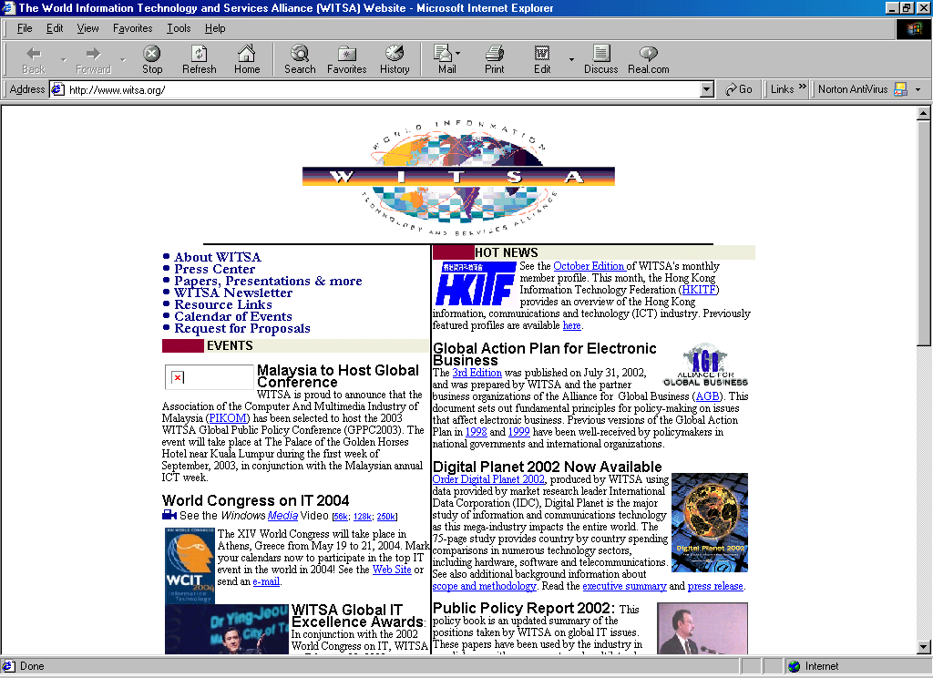
- Building a network for leader awareness, such as, Digital Divide Network, as initiated by Benton Foundation (www.benton.org) is an excellent approach.

In telecommunication and information technology industries,

- Privatization & competition in telecommunication industries will not totally solve rural telecommunication infrastructure problem. Most private industries would prefer to make money rather than deploying in commercially unfeasible areas.
- Universal Service Obligation (USO) – can be used for building the rural, schools etc. USO funding should be administered by an independent body, e.g., government, but not by the Incumbent operators.
- USO funds should be used not necessarily for the need of Telco companies, but should aim for community’s needs. Thus, USO should be designed to allow the community, rather than the incumbent operators, to get access to USO funds. Community education on such fund would likely be most strategic.
- Community based school network would be the most strategic thing to do; funding may be obtained from USO or other funding sources, such as, USAID etc.
- Network of small independent telephone companies and cooperative much more suitable and agile in adapting technology, providing advance services for rural and underserved areas.
- Internet should be considered as information services rather than telecommunication services, and it should be unregulated. The government should take hands off policy.

Some practical hints,

- Inform decision makers. “e-streets” seen FIRST. “Sweep” web sites before main street. Personal / business decisions made on “Web view” of community.
- “Some people change when they see the light. Others, when they feel the heat.” (R. Terry McGhee).

Lesson Learned – In Grass Root Movements

Some of the main points learned in many grass root movements, namely,

- Youth are the strategic agent of change, do educate the youth and they’ll change the future, the society as well as the culture.
- Build the usefulness of technology into the values of the culture.
- Demand creation is the important factor.
- Networking among non-profit organizations, business sector as well as government would play an important role.

Some of more fine points of the lesson learned in grass roots movements can be described as.

In education sectors / aspects,

- Start with library network, content would be difficult in Indonesia, as Indonesians are not generating sufficient content.
- Best of all, use play while you learn approach.
- Use “show me” method. Demo solutions of specific business or individual interests.
- Recognize success. They’ll start asking things like “Could I do this with that?”
- Any topic but technology would drive demand for technology. Build the usefulness of technology into the values of the culture.

In telecommunication infrastructure sector / aspects,

- Network of small independent telephone companies and cooperative much more suitable and agile in adapting technology, providing advance services for rural and underserved areas.
- Look for maximum bang for the buck, and, thus, look for maximum impact. Say integrating 100 schools / university would leads to integration of 100.000 students to the Internet. Some may argue that integrating schools to the Internet would also educate the terrorists; a more fine research should be performed to see if it is true.
- Don’t seek, hire, or maintain IT staff members that are not GLAD to share what they know – if asked. Avoid big fish, small pond techies (10+ years of “first year” experience). Hire pragmatic technology visionaries.
- Community Tele Center (CTC) approach would blends technology to the need of the community. CTC may buy bulk of bandwidth from the local ISP to be distributed to the local communities. Organize weekly meeting by volunteer at CTC to educate the communities and creates demand.

Desperately needed practical hints to survive,

- Think like a new competitor. Study the market as if a new comer. Be proactive, not reactive. Access your strengths and weaknesses. Acknowledge weaknesses and play to strengths. Use assets as competitive weapons. Keep a focus on your core strength.
- Remember the customer. Our customer is our paycheck. Listen to the customer. Attitude determines quality of service. Our relationship with our customer and the customer’s satisfaction determines loyalty more than our price. Word of mouth advertising is 50 times more powerful than media advertising. Company policy usually is written on the company’s terms, not the customer’s. The secret to success of customer service is to start and stay positive. The customer’s perception is the measure of success.
- Remember your employees. Your team is your best asset. No secrets; we’re in this together. The golden rule works “Always go to other people’s funerals. Otherwise they won’t go to yours.” (Yogi Berra).
- Be confident. The biggest handicap in life is a bad attitude. Trust in yourself and your organization.

Lesson Learned – In Alternative Technology Solutions

Some of the main points,

In physical network solutions,

Low Earth Orbit (LEO) Satellite, such as, the one run by VITA, is one of the alternative solution for rural areas. A compact, plug and play ground station is currently being built to enable them to deploy more rapidly. Although, getting funding would still be a problem.
- Store-and-forward email-based system for LEO Satellite. At 9600bps, it provides each station with 350Kbytes of data transfer.
- Webmail access, such as, the one to access VITA database, is an interesting approach especially for remote / rural areas with low throughput network.
- With multimedia data transmission capability and 5% of total WorldSpace bandwidth at its disposal, the WorldSpace Foundation’s Learning Channel is a valuable communication resource for developing countries.
- Wired solution might be feasible in rural areas, one should be careful in comparing all the investment & maintenance cost to implement wired & wireless in rural areas.

Some content examples,

- VITA-CONNECT (http://www.vita-connect.org) is a good example of non-commercial, humanitarian and development-focused communication and information service targeted to remote project offices, NGOs, rural communities, community radio stations, small business support organizations, schools, clinics, remote ecological data collection stations. It develops content based on dialogue with its community of users, which basically managing the tacit knowledge. Starting with its own library of proven technical information resources, VITA-CONNECT is collaborating with leading sources of practical information to build a portfolio of hands-on, useful information resources organized around discrete sectors.
- As high telecommunication cost would likely to render most of information &6 knowledge delivery activities. Genuine creativity is desperately needed in most cases, such as, use 120Gbyte harddisk and sneakers net to build digital library and manually transfer the knowledge in 3rd world country.

High lights on various aspects will be described in the next sections.

Youth The Agent of Change

Youth and young ones are very enthusiastic about technology and new things. They are the most strategic agent of change in the society. It is a long-term process, one need to have the passion to perform such process.

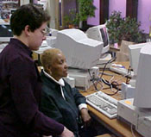
Some of the pictures show the effort performed by Pennsylvania Service Learning Alliance. Shown in the picture is Faith Goldstein, Coordinator Digital Divide Project helping one of the teacher on practical computer knowledge.
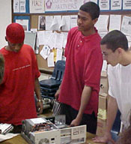
As Faith told me that the ways they do things, i.e., bridging the digital divide, are indirectly through the high school students. Work included refurbishing PC’s, facilitating deliveries of donated computers, networking refurbished computers, and using digital media to document their work. Student-developed digital video public service announcements educating the community about the issue of the digital divide. Installation of computers labs in schools with the help of students.

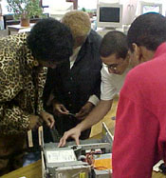
Dell TechKnow Summer Institute, in which middle school students rebuilt computers, installed software, and took the computer they refurbished home! Technology workshops for teachers and community members, facilitated by high school students, topic included basics, web design, Internet search and a job-readiness series.

Depending on the location of the schools, in poor urban areas, the students may be concentrating their efforts on their own school. In rich suburban areas, the high school students are really helping their surrounding communities and neighborhood.

In rural areas, schools are definitely the strategic agent of change as most of the communities are normally come together and use school as gathering place.

Play While You Learn
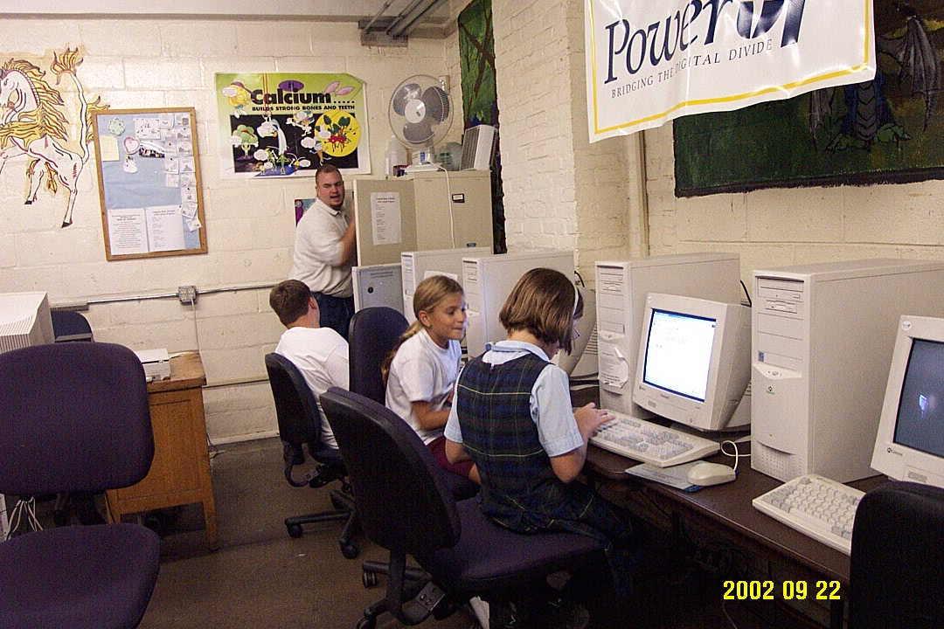
Shown in the picture are some of the activities at Boys and Girls Club of America (http://wwwbgcphila.org) located at Philadelphia.

Play while you learn seems to be an excellent approach. I talk to these young ones (6-7 years old); it surprisingly takes them minutes on the Internet to find the answer for the questions ask by the teacher.
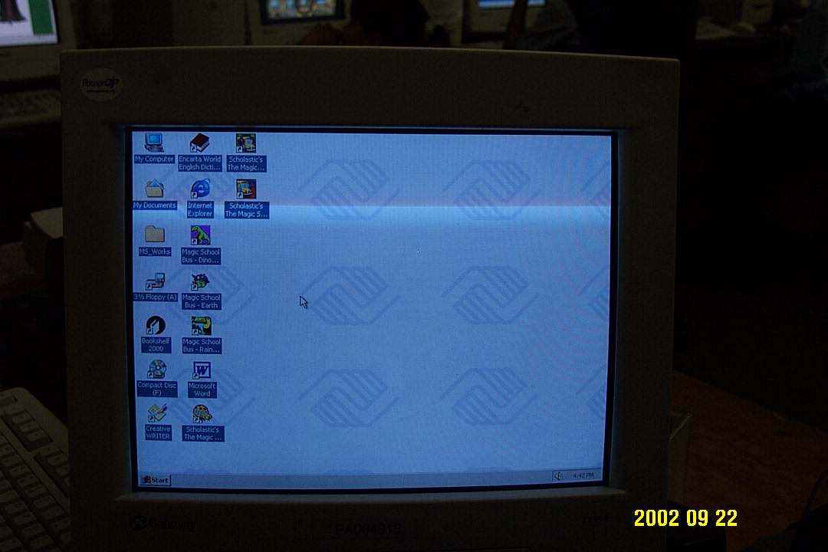
One of the major difficulties for the teacher as well as the curriculum designer is putting the learning concept in layman words. It is the most difficult part in most education processes.

The PC desktop is set to aim for easy maneuver and learning for the kids. Thus, all they need is to click an appropriate icon on their desktop.

Rural Telecommunication

Started by electrifying the American rural, the Rural Utility Services of US Department of Agriculture http://www.usda.gov/rus/ manages to empower the telecommunication sector in American rural. The ability to build & the survival of rural telecommunication is the key in bridging digital divide. “Hands off” regulatory framework seems to be the key in enabling independent telco in rural to be flourished.

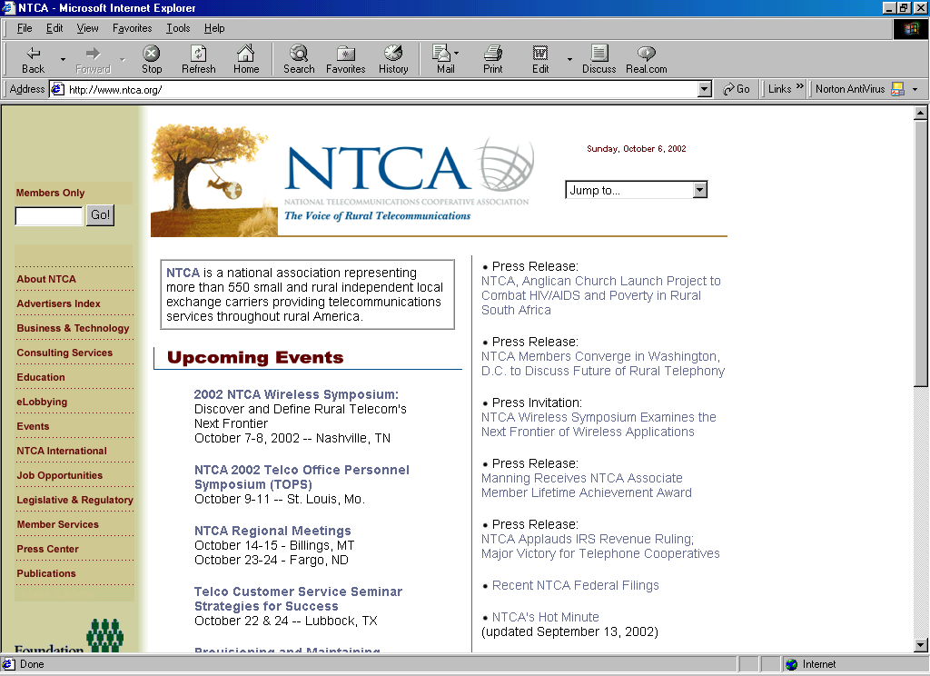
The result in 2002, there are approximately 1,000 independent telephone companies in the United States. The National Telecommunication Cooperative Association NTCA http://www.ntca.org is becoming one of the vocal point of these independent telephone companies. NTCA's more than 500 telephone cooperative and commercial companies have more than 3.1 million subscribers. The average number of access lines among NTCA's members is 4,000. The customer bases of NTCA members ranges from less than 100 to more than 50,000. The average number of employees among NTCA's members is 23. Approximately 2 million rural residents are served by telephone cooperatives in the United States. Bell operating companies, on average, serve 130 customers per mile of line. In contrast, the highest teledensity among NTCA members is 7 subscribers per mile of line, and on the low end, one customer per 10 line miles.

Interestingly, as these independent telcos are such as small companies, agility to adopt and deploy new technology is much better than the incumbent telcos. It is not surprising to see DSL lines and fiber optics to American rural.

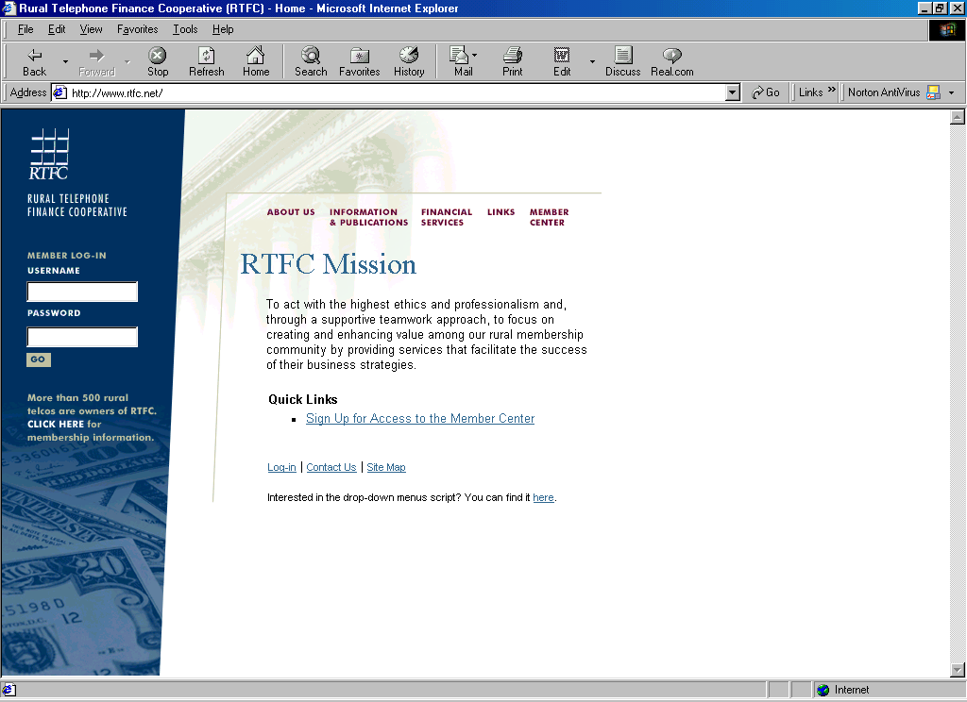
USDA traditionally acts as funding agency, rural telecommunication operator get the loan and they have to return it after 12-15 years, approximately the time when the equipments wears out. In addition, technical assistance in business plan etc. is also provided.

Currently, the Rural Telephone Financial Cooperative RTFC (http://www.rtfc.net) is providing financing services to rural telcos. They do short term loans, intermediate-long term loans, various interest rate options, as well as various ways of investment financing.
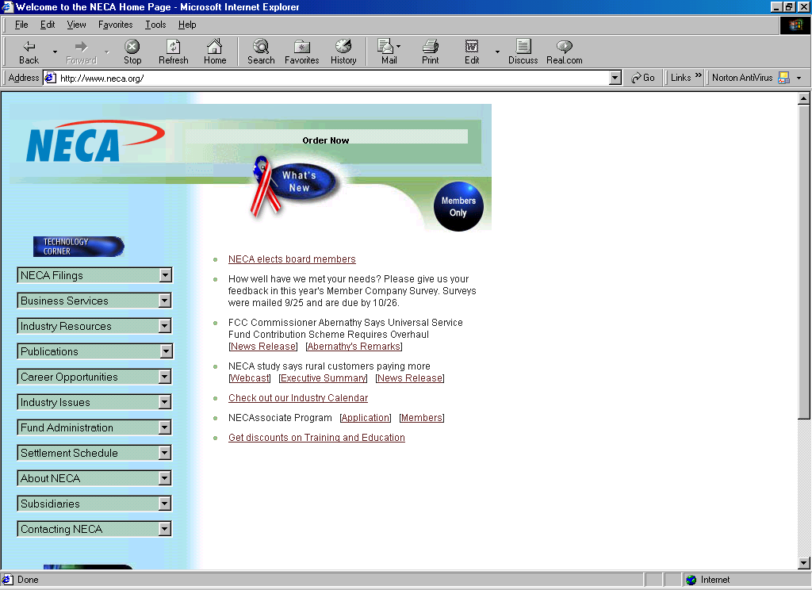
Interconnection is a big issue in telecommunication industries. By aggregating rural traffic, the independent rural telcos may gain higher bargaining power towards the big incumbent telco operators. They may than get a better bargain for their traffic. One of such interconnection point is the National Exchange Carrier Association (NECA, http://www.neca.org).

Experienced In Helping 3rd World Countries

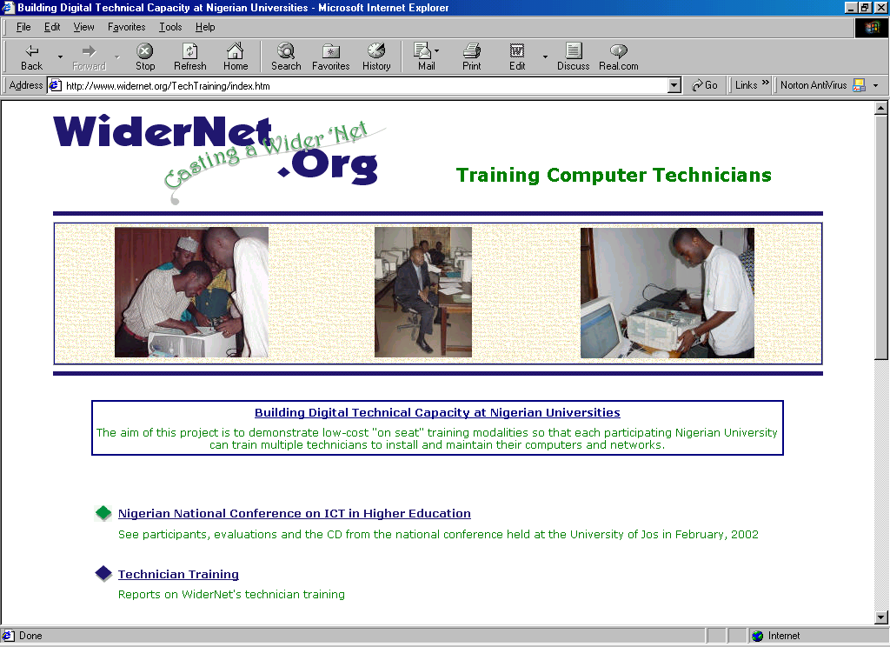
Dr. Cliff Missen and his group at WiderNet (www.widernet.org) at University Iowa has been for years helping African Universities to gain knowledge using electronic media and the Internet.

Human factor is found to be the critical factor in technology adoption by Nigerian Universities.
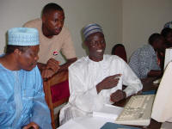
There are several major WiderNet activities with African universities, namely,

University linkages. Linkages the WiderNet Project, the University of Iowa, and Nigerian Institutions.

Training technicians at Nigerian Universities. Building digital technical capacity at Nigerian universities: Laying the foundation for greater digital participation and collaboration. Having the knowledge, the technicians drive the deployment of computer networking in Nigeria. Some of the course materials are provided on CD-ROM as well as Web over the Internet. Thus, dependency on teacher can be minimized.

Coaching Nigerian university decision makers. A Partnership between the University of Iowa and the University of Jos and the University of Ibadan, Nigeria. Hoping the decision makers will then support the network expansion within their universities.
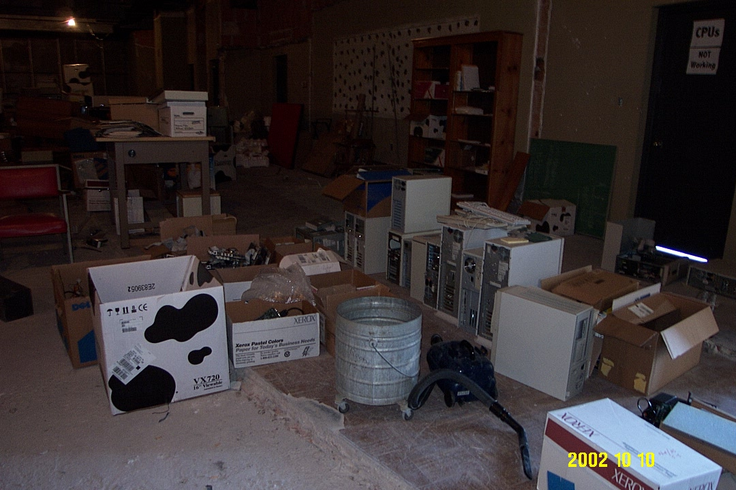
Computer and networking donations for African universities. Computer donation and shipping project to Nigeria. Collected donated computers are refurbished prior to shipping.

Classroom and corespondence curses at the University of Iowa. Internetworks in International Development.

The WiderNet Project Digital Library. Delivering hundreds of thousands of digital documents to African universities on 120Gbyte harddrive, and, thus, significantly trimmed down the dependency to the Internet. Work is currently underway to deliver the update of the materials via World Space digital satellite radio.
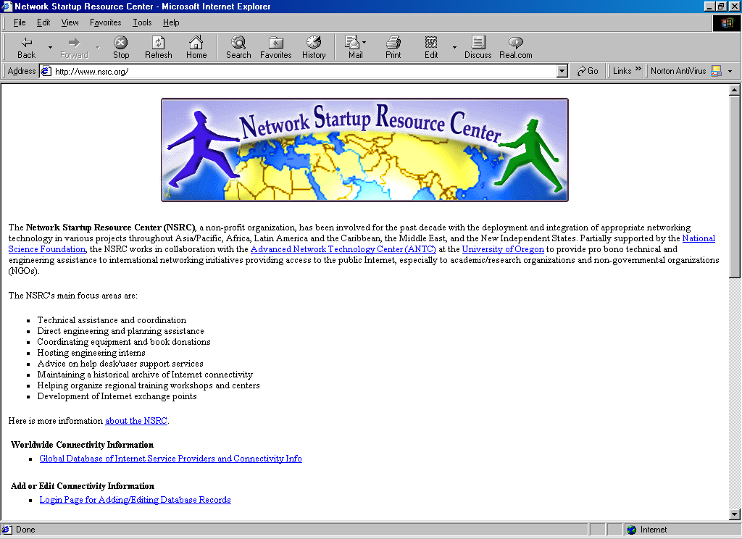
The network startup resource center (NSRC) based in Eugene, Oregon might be one example of a unique non-profit organization in the deployment and integration of appropriate networking technology in various projects throughout Asia/Pacific, Africa, Latin America and the Caribbean, the Middle East, and the New Independent States.

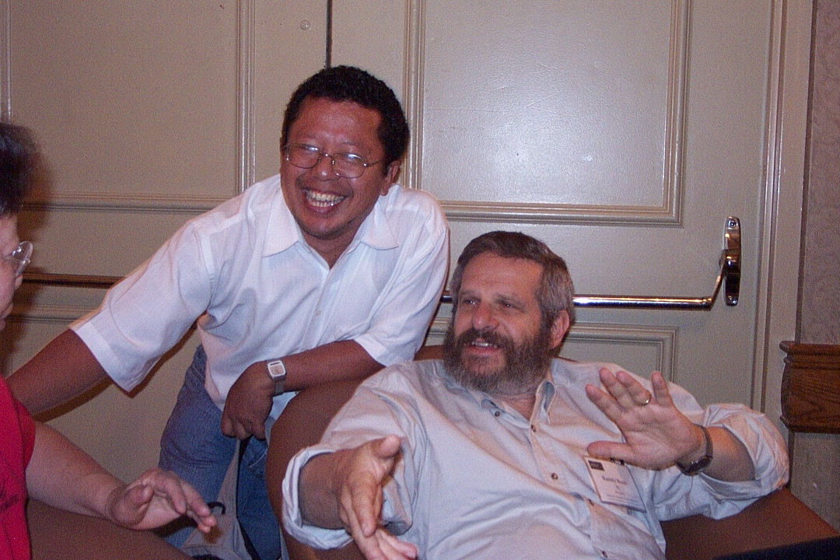
The NSRC's main focus areas are technical assistance and coordination, direct engineering and planning assistance, coordinating equipment and book donations, hosting engineering interns, advice on help desk/user support services, maintaining a historical archive of Internet connectivity, helping organize regional training workshops and centers and development of Internet exchange points. Some of the tools and publications can be freely downloaded from the their site at http://www.nsrc.org.

It is interesting to note that Randy Bush of NSRC (randy@nsrc.org), currently member of Internet Initiatives of Japan IIJ, is one of the person who help the first Internet connection in Indonesia almost a decade ago when we met for the first time. A reunion among us is taken place during the Eisenhower Fellowship.

Helping poor and 3rd world countries are not monopolized by non-profit organizations, several good profit companies are making significant contribution towards global society. Hewlett Packard (HP) with e-Inclusion program http://www.hp.com/e-inclusion/en/ is one of the good example.
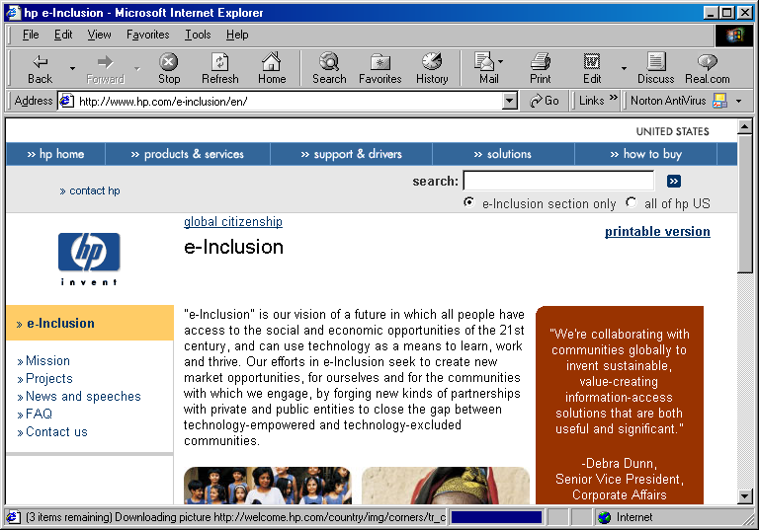
"e-Inclusion" is HP vision of a future in which all people have access to the social and economic opportunities of the 21st century, and can use technology as a means to learn, work and thrive. HP efforts in e-Inclusion seek to create new market opportunities, for themselves and for the communities with which HP engage, by forging new kinds of partnerships with private and public entities to close the gap between technology-empowered and technology-excluded communities.

Some of the example activities are Dikhotole Digital Village in South Africa to raise the community out of a cycle of poverty; Digital Garage in Sao Paulo, Brazil to merging music and technology to inspire underprivileged youth; Kuppam i-Community in Andhra Pradesh, India to accelerate economic growth and access to new markets and several other activities. Debra Dunn, HP Senior Vice President for Corporate Affairs once said "We're collaborating with communities globally to invent sustainable, value-creating information-access solutions that are both useful and significant."

Community Tele Center
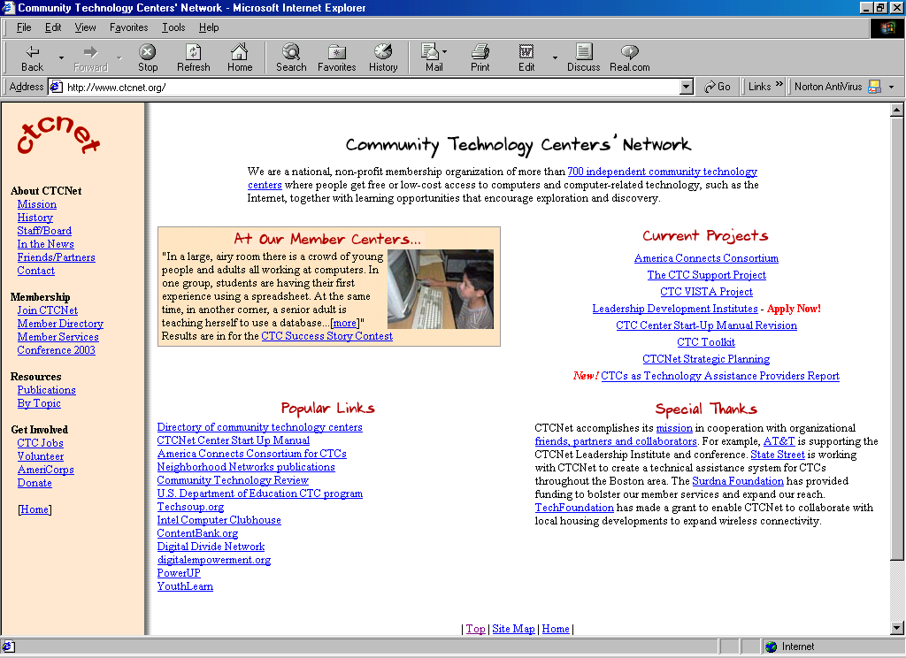
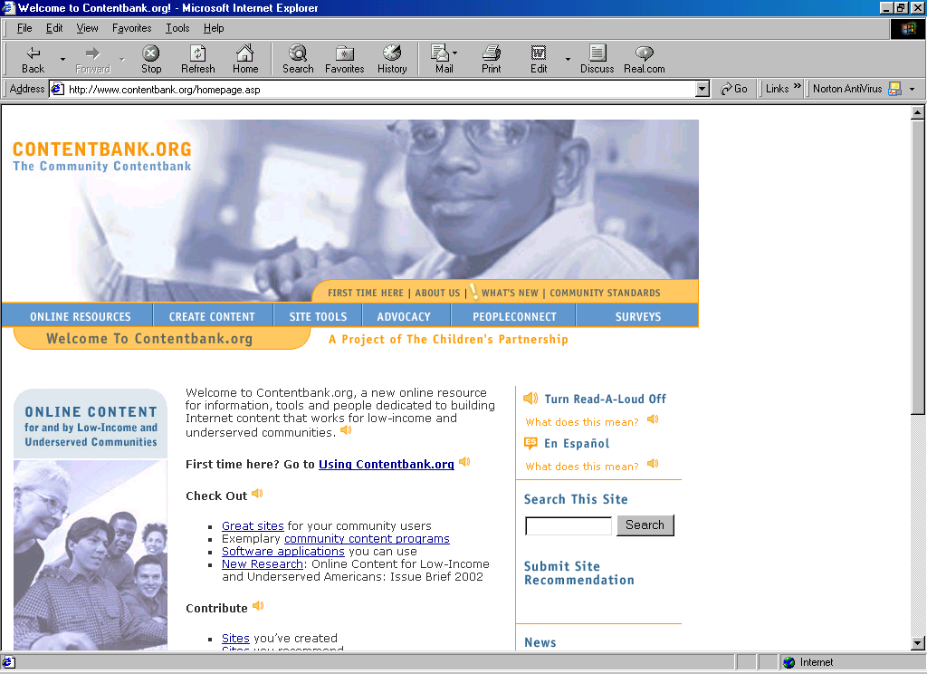
Education is the key in injecting any cultural evolution within the society. There are several community based learning activities performed by volunteers in the US. Most of them are organized around Community Tele Center activities at http://www.ctcnet.org. Community Tele Center (CTC) http://www.ctcnet.org is a non-profit activity to provide low cost & education to the community. Continuing education and practical computer skill classes are common, and hoping to be able to add values to adult communities to gain a better life especially in poor neighborhood. It is interesting to note that providing free education is not that easy, quite high resign rate occurs in such classes due to various reasons. Networking and support from various organizations on community centers, are apparent. One of such networking and support center is the CTCNet http://www.ctcnet.org. One may find the needed teaching materials online, such as, in www.contentbank.org.

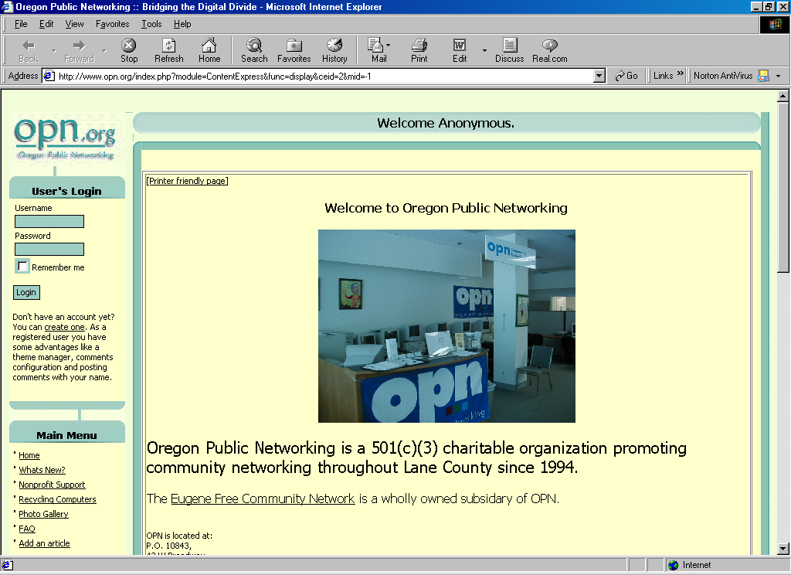
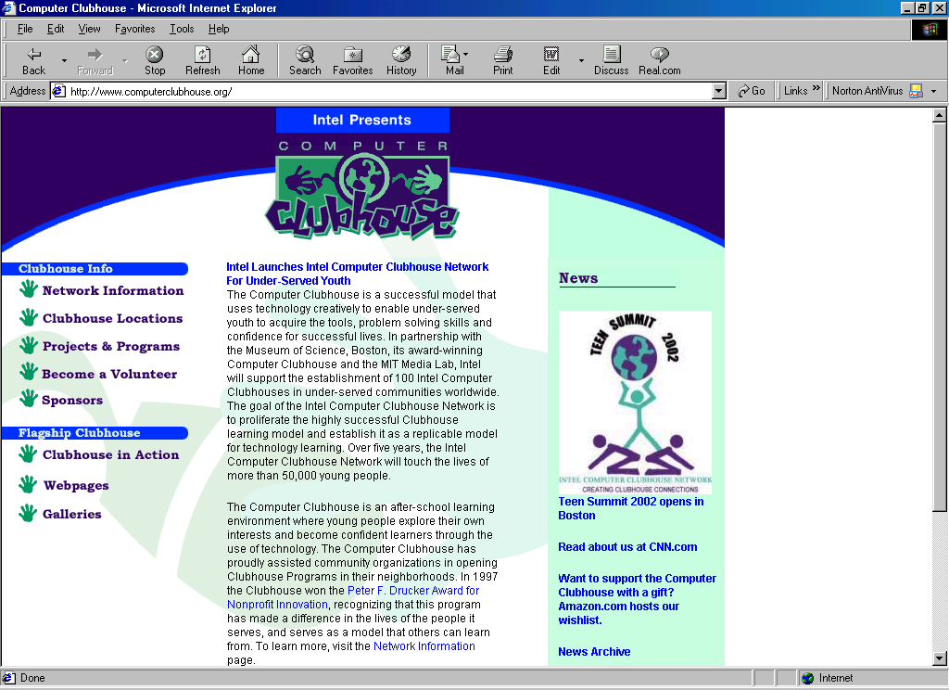
Some organize hobbyists to get organized and informally transfer the required knowledge among those who are interested. One of such organization is Computer Club House http://www.computerclubhouse.org. It helps the use of technology to empower the under-served youth to acquire the tools, problem-solving skills and confidence for successful future lives.

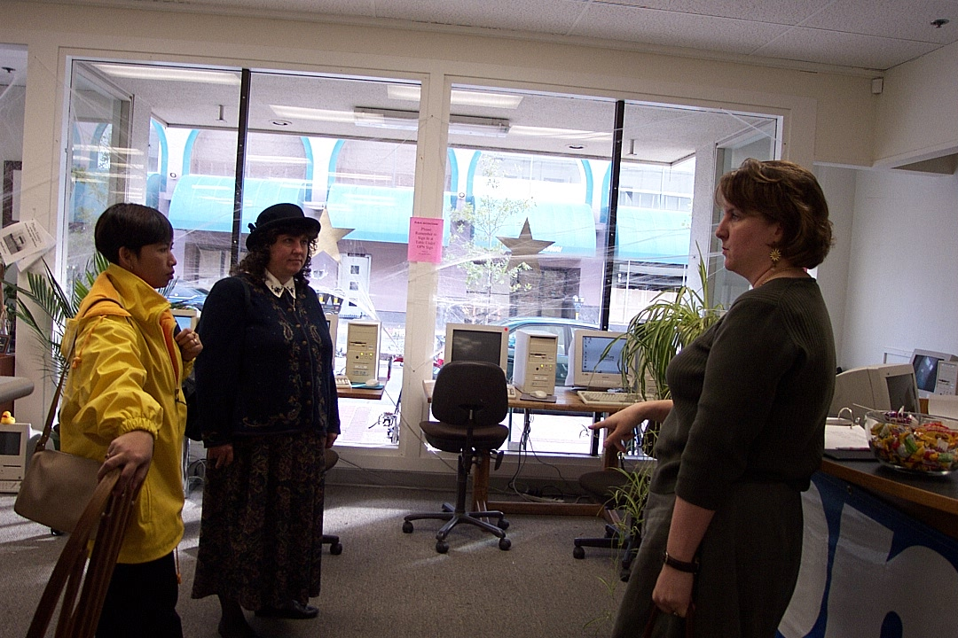
Some CTC, such as, the Oregon Public Networking, OPN (http://www.opn.org), try to empower the citizens to use advanced technology to create an informed, democratic community. They pursues this mission through several program areas, such as, free education and free training for the community, technology accessibility projects, knowledgeable advice and consultation, and support for local nonprofits. Shown in the picture is Sarah Wayland of OPN explaining on OPN free community education program to Lina Purbo and Cindy Weeldreyer, Lane County Commissioner.

In addition, OPN is an approved redistributor for local city and county surplus computers and equipment. If your nonprofit agency or program is in need of a computer, OPN can probably help you out. OPN offers working computers, Pentium 166 or better, to local nonprofits that request the equipment.

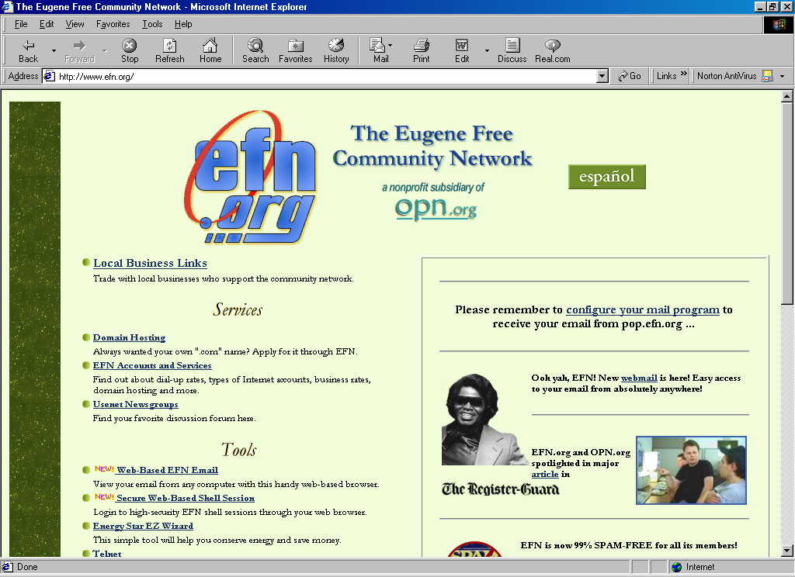
OPN sponsors public Internet access at locations throughout Eugene. OPN primary public access site is located at the OPN Community Technology Center, in downtown Eugene, Oregon. They run the center in conjunction with their affiliate organization the Eugene Free Community Network (http://www.efn.org)

EFN provides the necessary tools for free community network, such as, Web-Based EFN Email, Secure Web-Based Shell Session, telnet, free downloads, domain hosting, as well as search facility to find what you are looking for on the Internet. Having such tools eventually help various communities to electronically grow in many areas, such as, on children & family, culture, arts, humanities, economics, business, labor, education & libraries, environment etc.
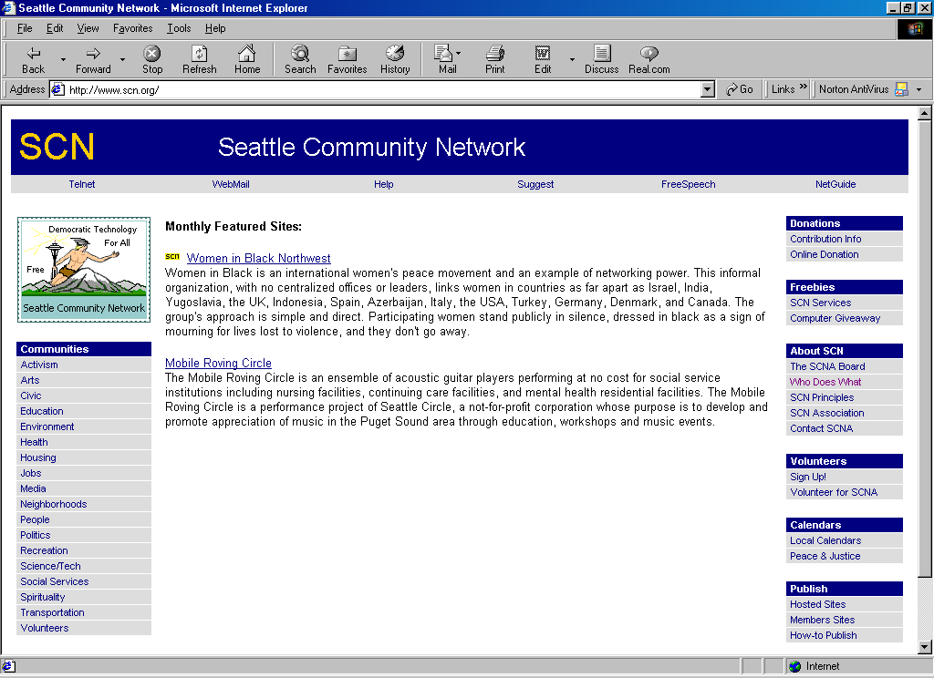
EFN is not the only Free Network in the US. There are several Free Networks linking the communities to various other communities, especially educational institutions and the public library. Another example of such community networking is the Seattle Community Network (www.scn.org), that provides free text based Internet access to Seattle communities.
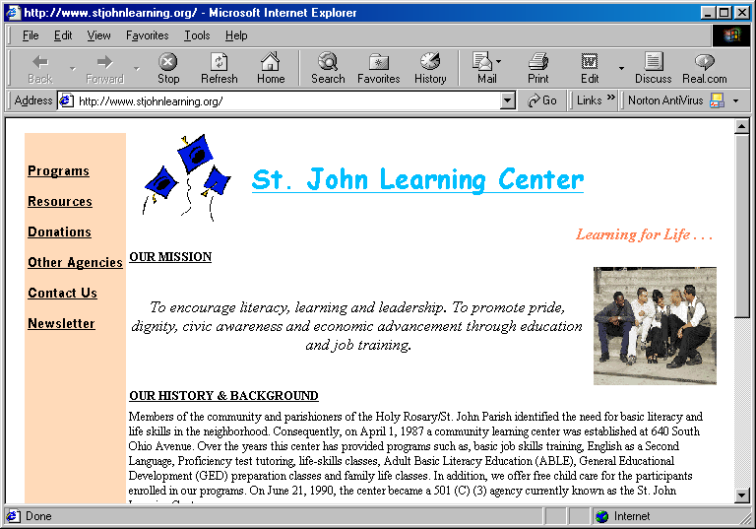
Some non-profit organizations will focus on helping their adult to improve their literacy, learning skills, and overall ability to succeed in the modern world. A good example of it is St. John Learning Center in Columbus, Ohio. Example of free programs available to the communities are computer training including Internet), GED classes with child care provided, home child care provider training, ESEC office skills training program and family literacy program.

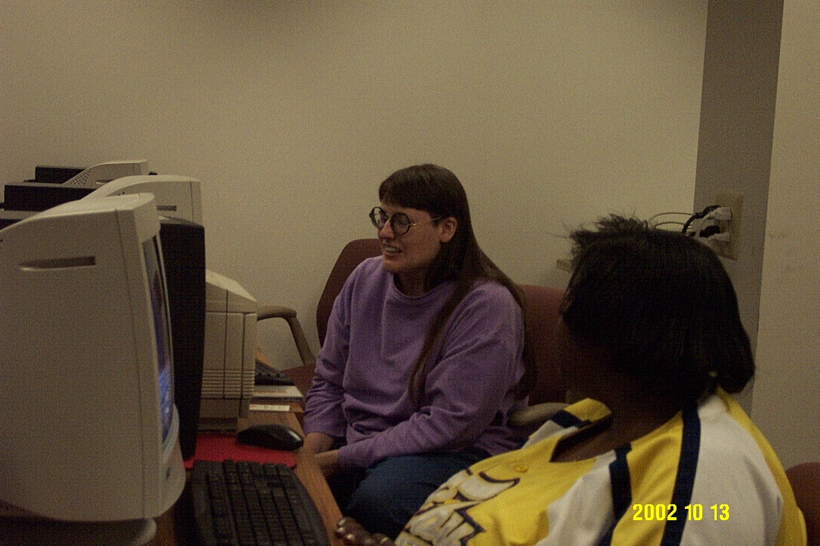
To perform such function, St. John Learning has many different resources available to participants and the community. The focus is to provide the support that clients need in order to advance their lives & careers to the next level. At various time during the year St. John Learning Center offers special workshops & events highlighting a resource important to families in the community. These resources include ongoing career counseling, job postings, job search databases, Internet access, resume' assistance, information on the college admissions process and tax preparation assistance.

Professional IT Education for Colored Young Americans
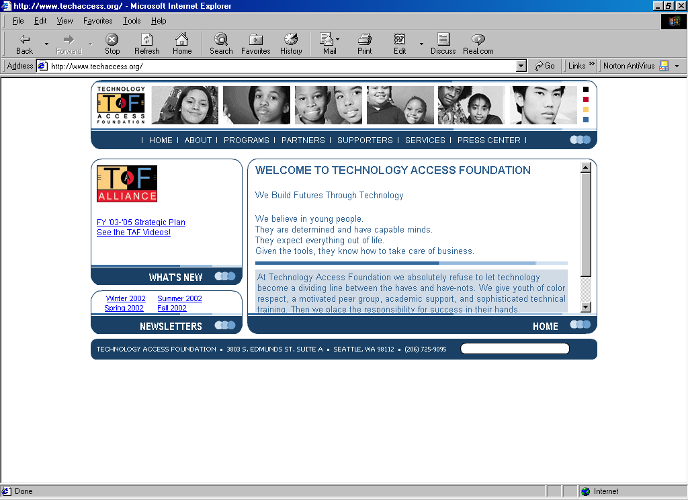
Technology Access Foundation TAF http://www.techaccess.org might be one of the best organization that really push colored young American towards their limit to be an IT professional in their early age. They believe that the children in American communities need the following to have a chance at a successful future:

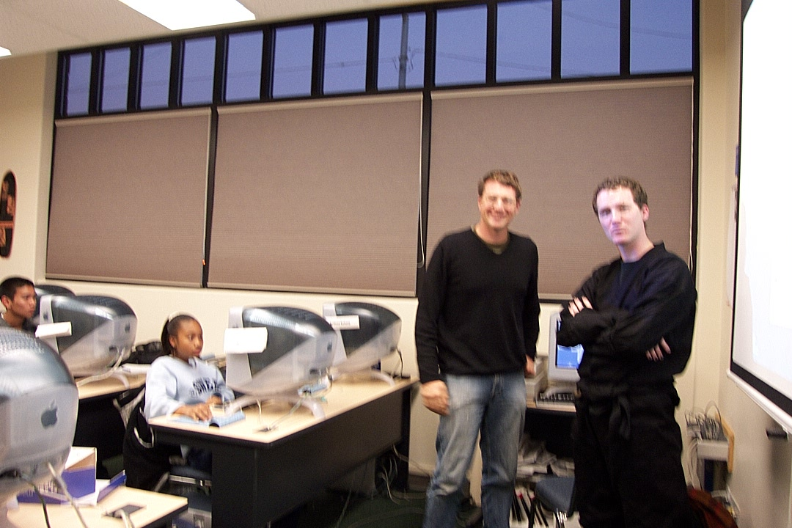
- a solid foundation in math, reading, communication, problem solving, and critical thinking skills.
- computer fluency skills (operating knowledge, desktop tools, internet use, and basic programming skills).
- information literacy skills (searching for, organizing, synthesizing and producing information).
- educational and employment opportunities.
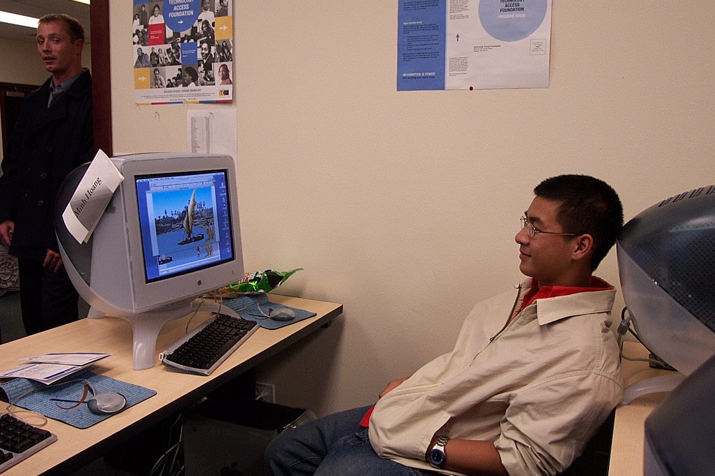
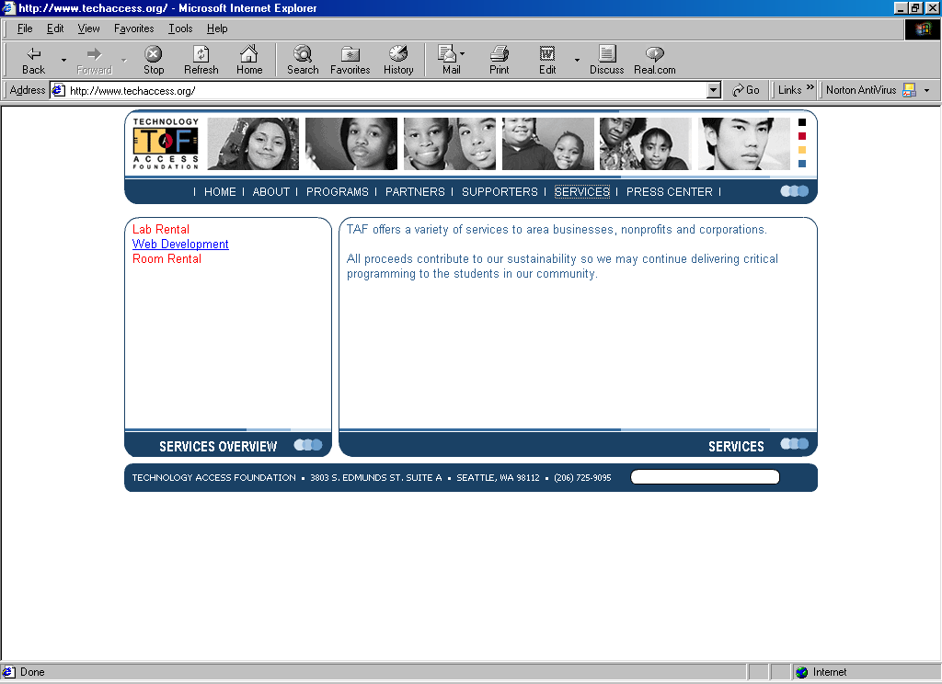
taken together, families, community organizations, schools, businesses, and governmental organizations possess all the necessary resources to develop an environment where American childern can succeed. Those who wants to take an important role in providing many of the resources needed to ensure American chilldern's success, must be able to work with all the above stakeholders.

Technology Access Foundation grown since 1996 from staff of 4 in 1996 to a staff of 15, budget grown from $100K to $1.27M and trained over 500 students in computer fluency. On TAF technical teens internship program, 100% of the 55 students who graduated high school while still in the program are in college. The program has enjoyed an 85% retention rate. Over 110 students (80%) have received paid high tech summer internships. Students contributed over 4,500 volunteer hours doing such things as developing websites for nonprofits, teaching/tutoring younger students, and speaking at TAF events.

Their TAF TechStart program managed to educate over 150 students ages 7-12 to complete programming at Rotary Boys and Girls Club and the African American Academy. While TAF Higher Ed Bound has successfully completed first pilot with 13 Seniors and 15 Juniors. 11 out of 13 students attending one of their top choice four year schools.

Keep that in mind that all of these activities are free to the students. A rigorous selection process is performed to select the dedicated young & color students. These students are mostly coming from poor neighborhood in Seattle areas.

APPENDIX

List Of Organizations / Contact Persons Visited

Policy & Regulatory Framework
Eric Johnson, Internews
Email johnson@internews.org
Web www.internews.org, www.internews.or.id, www.gipi.or.id

Dr. Anthony Wilhelm, Vice Programs Benton Foundation
Benton Foundation
1625 K Street, NW
11th Floor
Washington, DC 20006
Phone: 202 638-5770 Fax: 202 638-5771
Email tony@benton.org
Web: www.benton.org

Anders Halvorsen, Program Manager
Information Technology Association of America ITAA
1401 Wilson Boulevard
Suite 1100
Arlington, VA 22209
Phone: 703 284-5333 Fax: 703 5252279
Email ahalvorsen@itaa.org
Web: www.itaa.org & www.witsa.org

Gary B. Allan, Chief, Universal Services Branch, Advanced Services Division
Ed Cameron, Advanced Services Division
United States Department of Agriculture -- Rural Utilities Service
US Department of Agriculture
14th & Independence Ave. NW - /room 2845
Washington, DC 20250
Phone: 202 720-0665, 690-4493
FAX 202 720-1051
Email gallan@rus.usda.gov
Web: www.usda.gov/rus

Robert Somers, Director of the International Visitors Program
J. Scott Marcus, Senior Advisor for Internet Technology
Federal Communications Commission
445 12th Street, SW
Room 6-C825
Washington, DC 20554
Phone: 202-418-1483, 418-0611
FAX 202-418-2807
Email bsomers@fcc.gov
Email smarcus@fcc.gov
Web: www.fcc.gov/opp, www.fcc.gov/ib/ivp, www.fcc.gov

Chris Israel, Deputy Assistant Secretary for Technology Policy
Kathryn Sullivan, Acting Director Office of International Technology
Joyce V. Watson, International Trade Specialist
U.S. Department of Commerce
Room 4814C
14th & Constitution Avenues, NW
Washington, DC 20230
Phone: 202-482-5687 Fax: 202-482-4817
Email chris.israel@ta.doc.gov
Email kathryn.sullivan@ta.doc.gov
Email joyce_Watson@ita.doc.gov
Web: http://www.ta.doc.gov

Diane E.V. Steinour, telecom. Policy Specialist
Don Druker, Technology Opportunities Program
James W. McConnaughey, Senior Economist
National Telecommunications and Information Administration
Herbert Clark Hoover Bldg, US Department of Commerce
1401 Constitution Ave, NW
Washington, DC 20230
Phone: 202 482 0023 FAX 202 482 0023
Email dsteinour@ntia.doc.gov
Email jmcconnaughey@ntia.doc.gov
Email ddruker@ntia.doc.gov
Web: www.ntia.doc.gov

Donald C. Hellmann, Professor, International Studies. Director, Institute for International Studies.
Christopher T. Coward, Director, Center for Internet Studies.
University of Washington
Box 354846. Seattle, Washington 98195-4846
Tel 206-616-9082, 206-616-9100
FAX 206-616-6982
Email hellmann@u.washington.edu
Email chrisc@cis.washington.edu
Web www.cis.washington.edu
Web www.iip.washington.edu

Delia Burke, Computer Technology Planner, Community Technology
City of Seattle, Department of Information Technology
Key Tower
700 5th Avenue, Suite 2700
Seattle, WA 98104
Tel 206-233-2751
Email delia.burke@seattle.gov
Web www.seattle.gov/tech/

Grass Root Movements

Faith Goldstein, Coordinator Digital Divide Project
Pennsylvania Service Learning Alliance
Phone: 212-573-2380
Email: faithg@sas.upenn.edu
Web: www.delawarevalley.org/psla/index.html

Alina Whittle, Director
Bridesburg Boys & Girls Club
2901 Bridge Street
Philadelphia, PA 19137
Phone: 215-743-7755
FAX: 215-7442241
Email: uhleenuh1969@cs.com
Web: www.bgcphila.org, www.bgca.org

Sue Lambertz , The Iowa Alliance for Advanced Telecommunications Services
Steven R.McCann, Division of Community and Rural Development
Philip L. Thomas, Business Development Division
Iowa Department of Economic Development
200 East Grand Avenue
Des Moines, IA 50309
Phone: 515-242-4922
Email sue.lamberts@ided.state.ia.us
Email steven.mccann@ided.state.ia.us
Email pil.Thomas@ided.state.ia.us
Web: http://www.state.ia.us/ided/crd/telecomm/alliance.

M. Thomas Sepic
President & CEO
Iowa Telecommunication Association
2987 100th Street
Urbandale, IA 50322-3881
Phone: 515-867-2091
Email tsepic@i-t-a.net
Web: http://www.i-t-a.net

Richard M. Vohs
President & CEO
Iowa Network Services, Inc.
4201 Corporate Drive
West Des Moines, IA 50266-5906
Phone: 515-830-0474
Email rmv@netins.com

Judy Pletcher
Rural Iowa Independent Telephone Association.
1000 Walnut Street, #324
Des Moines, Iowa 50309
Phone: 515-243-1743
Email pletcher@netins.net
Web: www.riita.com

Michael “Mike” J. Bacino, Executive Director
Robert Schmit, Engineering Transmission and Circuit Manager
Tamara A. Fujinaka, Director, Public Affairs Division
Iowa Communications Network
P.O.Box 587, Building W4, Camp Dodge, Johnston, IA 50131-0587
Phone: 515-725-4707, FAX 515-725-4751
Email mike.bacino@icn.state.is.us
Email bob.schmit@icn.state.ia.us
Email tami.fujinaka@icn.state.ia.us
Web: http://www.iowanetworkservices.com, http://www.icn.state.ia.us

Dr. Cliff Missen, professor & founder of Widernet
226 International Ctr., Iowa City, Iowa 52242-1802
Phone: 319-335-2200 FAX 319-335-0280
Email cliff-missen@uiowa.edu, missenc@widernet.org
Web: http://www.widernet.org/

Angela Stuber, Executive Director
Ohio Community Computing Network
P.O.Box 361224
Columbus, OH 43236
Email astuber@ctcnet.org
Web: www.occcn.org/
Fax 614 428-4244
Business 614 428-8162

Stephani Johnson, Executive Director
Cynthia Newberry, Technology Director
Tracy Barnett, Americorps VISTA Volunteer
St. John Learning Center
640 South Ohio Avenue, Columbus, Ohio 43205
Phone 614-252-3132 x 250
Fax 614-258-3594
Email stephanijohnson@hotmail.com
Email newberryc@hotmail.com
Email tracybarnett@mac.com
Web www.stjohnlearning.org

Skip Rhodes, Corporate Manager, Community Involvement
Mylene B. Chan, Corporate Representative, Community Involvement
Bambang Pratesa, Technical Advisor Asia Pacific
ChevronTexaco Corporation
575 Market Street, San Fransisco, CA 94105-2856
Phone 415-894-5464
FAX 415-894-3583
Email jwrh@chevrontexaco.com
Email mbom@chevrontexaco.com
Email bpratesa@chevrontexaco.com
Web www.chevrontexaco.com

Marc Carr
Heather Wilson
Global Education Partnership
1411 K Street, NW Street 602, Washington, D.C. 20005
Phone 202-347-7043
1629 Telegraph Avenue, 5th Floor, Oakland, California 94612-2114
Phone 510-208-3405x14
Email mcarr@geponline.org
Email hwilson@geponline.org
Web www.geponline.org

Sarah Wayland, Executive Director
Tasha A. Zahn, Volunteer Manager
John, Technical Manager
Oregon Public Networking
43 West Broadway, Eugene, OR 97401
Phone 541-914-3470
FAX 541-484-6306
Email execdir@opn.org
Email tasha@opn.org
Web www.opn.org

Seth Cohn, General Manager
Eugene Free Community Network
43 West Broadway, Eugene, OR 97401
Phone 541-484-9637
FAX 541-484-6306
Email gm@efn.org
Web www.efn.org

Cindy Weeldreyer, Lane County Commissioner
60 Bennett Creek Road
Cottage Grove, OR
Email Weeldreyer@aol.com
Trish Millines Dziko, Executive Director
Technology Access Foundation
3803 S. Edmunds St., Seattle, WA 98118
Phone 206-725-9095
FAX 206-725-9097
Email trishmi@techaccess.org
Web www.techaccess.org

Akhtar Badshah, Ph.D, Executive Director
Digital Partners
World Trade Center, 2200 Alaskan Way, #455, Seattle, WA 98121
Phone 425-898-9739, 206-782-1252
FAX 425-898-9649
Email abadshah@msn.com
Web www.digitalpartners.org

Mark Rose, President & CEO
CommTech
Box 266, Brinnon, WA 98320
Phone mark@commtech.bz
Web www.commtech.bz
Web www.olympictechnet.com

Alternative Technological Solutions
George Scharffenberger, President, VITA
Volunteers in Technical Assistance
1600 Wilson Boulevard, Suite 710
Arlington, VA 22209
Phone: 703 276-1800 x 18
Fax: 703 243-1865
Email george@vita.org
Web: www.vita.org

James M. McGrane, Vice President and Chief Information Officer
Vicki L. Davies, Director, Policies & Standars
Paul M. Moorman, Director and Chief Technology Officer
MeadWestvaco Corporation
Courthouse Plaza NE
Dayton, OH 45463
Phone: 937-495-3546
FAX: 937-495-3958
Email jmm4@meadwestvaco.com
Email vld2@meadwestvaco.com
Email pmm@meadwestvaco.com
Web www.meadwestvaco.com

Walt Reichert, Manager of International Business Center
Hewlett-Packard Company
3000 Hanover Street
Palo Alto, California 94304
Phone 650-857-2032
FAX 650-857-7594
Email walter.reichert@hp.com
Web www.hp.com/e-inclusion/en/

Dave Rossetti, VP of Strategic Software Technology
Christine Hemrick, VP of Strategic Technology Policy
Cisco System, Inc.
300 East Tasman Drive, Building 10
San Jose, California 95134-1706
Phone 408-527-3777
FAX 408-527-5733
Email rossetti@cisco.com
Email hemrick@cisco.com
Web www.cisco.com

Steve Guest, Ph.D, Vice President, Board of Directors and Executive Director
Seattle Community Network Association
5485 Highland Drive, Bellevue, WA 98006
Phone 425 653 7353
Email steveg@scn.org
Web www.scn.org/scna/

APPENDIX – Some Web References

Application / Technology
www.bizpathways.org - community based business development.
www.oplympictechnet.com - olympic peninsula community
www.commtech.bz
www.positivelypella.org - community based business development.
www.hillsearch.org - business library.
www.icn.state.ia.us - state own broadband network services
www.iowanetworkservices.com - rural telecommunication network
www.vita.org - low cost satellite telecommunication network.
www.vita-connect.org - appropriate technology database.

Development Partners & Non-Profit Organizations
www.delawarevalley.org/psla - high school students helping community.
www.delawarevalley.org/urbantech - help getting computer donation.
www.bgcphila.org - after school activities for students.
www.bgca.org - after school activities for students.
www.widernet.org - helping African country to get connected.
www.ctcnet.org - community tele center site
www.minnesotaruralpartners.org - consultant in community technology.
www.communitytechnologyadvisory.org - consultant in community technology.
www.ch2m.com
www.ruralmn.org - rural minessota.
www.ntca.org - national telecommunication cooperative association.
www.neca.org - national exchange carrier association.
www.rtfc.net - rural telecommunication financial cooperative.
www.riita.org
www.computerclubhouse.org - helping underserved youth.
www.contentbank.org - sharing learning materials for learning community.
www.techaccess.org - helping young color in IT professional
www.scn.org - seattle community network
www.digitalpartners.com - partnership for digital divide
www.opn.org - oregon public networking
www.efn.org - Eugene free community network
www.nsrc.org - network startup resource center
www.geponline.org - global education partnership
www.techaccess.org - technology access foundation, helping color young in IT.
www.stjohnlearning.org - St. John learning center.

City / Government / National Organizations /
www.southsiouxcity.org
www.usda.gov/rus/ - rural utility services office.
www.ta.doc.gov/otp/ - office of technology policy.
www.ntia.doc.gov - national telecommunications and information administration.
www.fcc.gov - federal communication commissions
www.itaa.org - US based IT associatin.
www.witsa.org - world wide IT association.
www.benton.org - Benton foundation
www.cis.washington.edu - center for internet study

