Strategic Injection To Encourage Local Knowledge & Skill

Onno W. Purbo

Overall Perspective

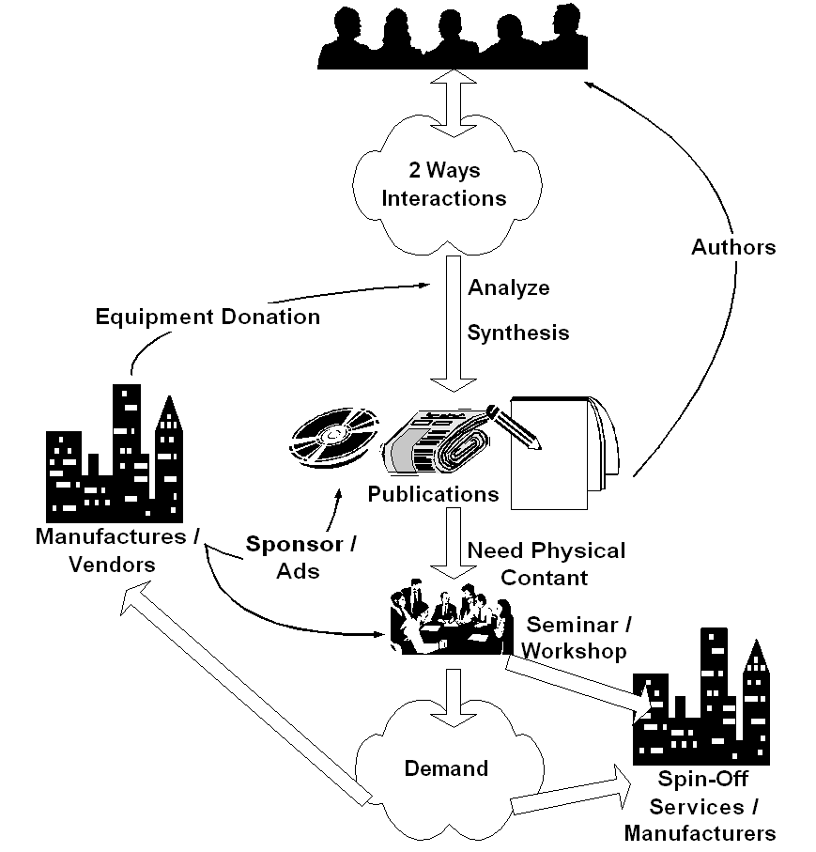
To sustain a digital divide bridge deployment, a supply created-by-demand strategy would be crucial. Most failed approaches will likely to use demand created-by-supply path. Demand in information infrastructure as well as ability to exploit the abundant information & knowledge in the infrastructure will only happen in an educated society. Failure to increase the society's level of education will likely to impede the development of information infrastructure within the society.

Key success in deploying the information infrastructure would rely heavily on the quality & skill of the human resources. Ability to distribute the needed knowledge & skill at low cost would be crucial in creating demand & needed skilled technician to deploy the infrastructure. Ability to access ICT knowledge in English would be a plus. Interestingly, please note that funding is not the primary concern in deploying ICT infrastructure.

If I may put it in point form, the simplified steps would be something like,

- Create platform for people to do 2 ways interaction. It is basically to facilitate tacit (implicit) knowledge exchange. It may be Internet mailing list at no cost.

- It may take 1-2 years, before some of the individual start analyze and synthesis the collective community knowledge. It is published in written form, such as, magazine, books. It cost US$ 1-2 to access the knowledge by buying the book or magazine. They will produce publications in magazine and books and receive US$ 25 / article or US$ 500 / book.

- Some may need physical contact through seminar and workshop to be convinced. We are normally looking at 500-1000 participants / seminar. It costs US$ 3 / person to enter such seminars as many vendors may likely give sponsorship.

- In the end, it creates demand within for the "digital divide bridge". Once the demand increases business will respond to the opportunity else persuade people to invest their money into deploying the "bridge". A 50 cents/student/month in a school network or US$15-30/house/month in a US$2000 neighborhood network investment with Return of Investment within 1-2 years is a good enough incentive for people to invest their own money into the "digital divide bridge". Success stories & word of mouth is the typical process to spread the words.

- Deploy & maintain the "digital divide bridge" may be done at 50 cents/student/month at school or about US$ 15-30/month/house. Ah, we finally have financially sustainable digital divide bridges with minimal support from the Bank, the government & hopefully license free.

- In the end, as more and more people connected to the Internet, pressure will be high for the regulators to work on their policies. Hoping no distortion made during the processes.

As shown clearly, all the sequences are self-finance. The normal (not the ideal) sequence would be awareness, demand, business response, and regulation. These steps would not be completed over night. It will take years to complete these steps. Committed leaders & personals are needed for such long-term deployment ICT movement.

What IDRC could do to facilitate the processes?

A careful intervention should be performed in one of the point in demand creating processes. It can be in

- 2-way interaction platform – to accumulate & manage community tacit knowledge.
- Information analyzing & synthesis processes. Testing & development processes.
- Encourage explicit knowledge creation, e.g., in book and article.
- Expedite explicit knowledge distribution.

Those are the processes that involving a large number of people. It is a long-term process, with very limited interest from commercial sectors to sponsor the process. The communities are currently relying on free services over the Internet.

Language barrier would be one of biggest barrier in south-south development strategies. It really impede the collaboration processes. I personally don’t know the best solution to such barrier.

Just to give some ideas on the kind of intervention by donor agencies to facilitate the process without disturbing the self-finance & sustainability process of the movement, some of them are,

- Creating free mailing list platform at the country’s Internet Exchange in confining the discussion traffic bandwidth in the country. It might be possible to work together with yahoogroups.com (http://groups.yahoo.com). To be honest, yahoogroups.com may be the best free mailing list service in the world today.
- Encourage knowledge producers. For example, having some sort of ICT book competition to encourage young authors.
- Supporting a development server. Where young programmers can try their ideas. In return, they have to publish their knowledge gain from their experiments, in terms of magazine articles, books, both in their local language and English as well as put their script and code under GNU License.

The development server might be the most strategic movement. For example, a lot of young Indonesian developers ask me if I have access to free web server with PHP & MySQL capability to test their script. If such approach would like to be performed, we can set the condition for these young developers to publish & share their work under GNU license if they use the server.

There are several prerequisites conditions to be considered, namely,

- The Development Server should be physically located at the national Internet Exchange for practical reasons, i.e., removing any bottleneck in accessing the service. In Indonesia, the Indonesia Internet Exchange has local bandwidth in the range of Gbps. It is good for the local ISP as we create demand for local connection while reducing the high cost International bandwidth. This may cost some money (funding).

- The local co-location service provider must do physical maintenance of the server. There are several co-location / hosting service provider in the country. This may cost some money (funding).

- The largest Open Source community in the country must transparently do access management of the development server. Kelompok Pengguna Linux Indonesia http://www.kpli.or.id is currently the largest Linux Open Source Community in Indonesia. Depending on the agreement, this may or may not cost any money (funding).

- Every individual / groups should be allowed to access to the development server under certain condition, such as,

  - All scripts / code must be published under GNU Public License (Open Source).
  - Must be able to proof publish articles in magazine.
  - Ability to publish book would be a plus.
  - Ability to publish work in English would be a plus plus.

