Tacit Knowledge Exchange

Trust is the main mechanisms to strengthen the bond and drive a community forward. After more than twenty years of field experience, talk and chat is the simplest form of mechanism to build trust within a community. On the Internet, Internet mailing list would be one of the mechanisms that fit into such simplest mechanism. If no physical and face to face interaction in the process, and all rely solely on virtual / Internet based mechanism, the trust building process might takes a years of daily interaction via e-mail mailing list. A physical or face-to-face interaction will likely to speed up the trust building process. Language would be a second major barrier.

Years of daily interaction in a mailing list is not only building the trust but also facilitating transfer of knowledge especially tacit knowledge among the participants. In this chapter, we will discuss both knowledge transfer process as well as trust that can move the community forward.

Informal Visionary Leaders & Activists

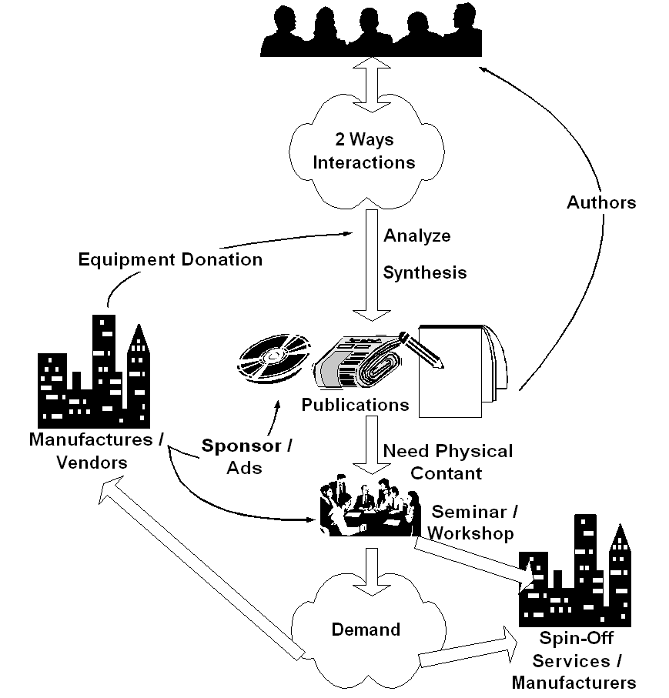
The most difficult task is to drive the mass within various mailing lists, one should understand techniques, such as, information warfare and psychological warfare, to lead such mass. It is an art in itself. Only knowledgeable leaders will be respected by the communities and would be able to drive communities in cyber space. These leaders would take initiatives and lead the mass, which, unfortunately, in some cases, would put his or her in the opposite side to the Indonesian government policies. In contrast, those bureaucrats, government leaders who normally get their position through normal carrier promotion processes and would likely to fail in dealing and driving such community masses.

In the process, printed and electronic media, such as, magazine, books, radio and television, play a significant role in setting the mid set of many Indonesian that are not yet on the Internet. Many journalists are on the Indonesian mailing lists and monitoring community activities and report it to the common audience through their media conveying the message from cyber space.

It is all part of self-finance community education process that leads to self-finance sustainable digital divide bridge building.

The actual informal visionary leaders and activists can easily found on the Indonesian Internet mailing lists. Most of them are young people around 25-30 years old. Some of them run the local cybercafes, local computer shops, and dedicated vocational teachers. These leaders and activists are normally a common people who make changes in their surrounding communities.

Only those trusted, knowledgeable & proved to be dedicated to the communities in long period of time would be received the highest level of trust from the Indonesian Internet communities. There are only handful persons that received such highest level of trust from the communities. These are the real informal Indonesian Internet leaders and mostly not government officials.

Free Mailing List @ Yahoogroups.com

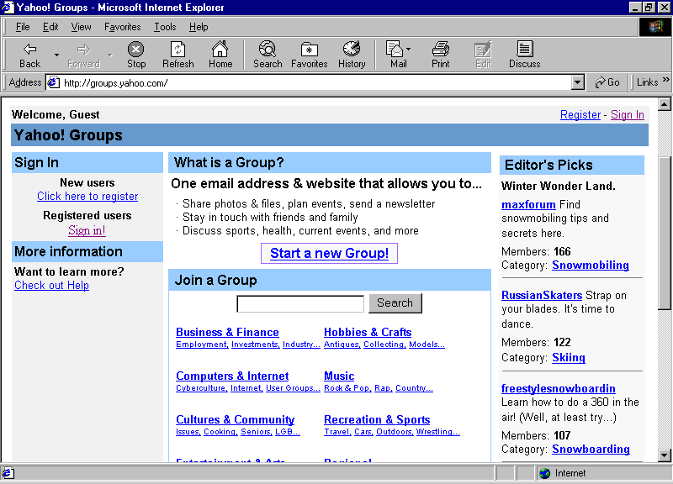
The evaluation process of the characteristics of Indonesian community on the Internet can be easily performed at http://groups.yahoo.com. Shown in the figure is the home page of http://groups.yahoo.com. To find Indonesian communities on the net, one can enter Indonesian keywords and press “search” button. In the evaluation process, I use 100+ keyword to find 45.000+ Indonesian mailing lists on http://groups.yahoo.com.

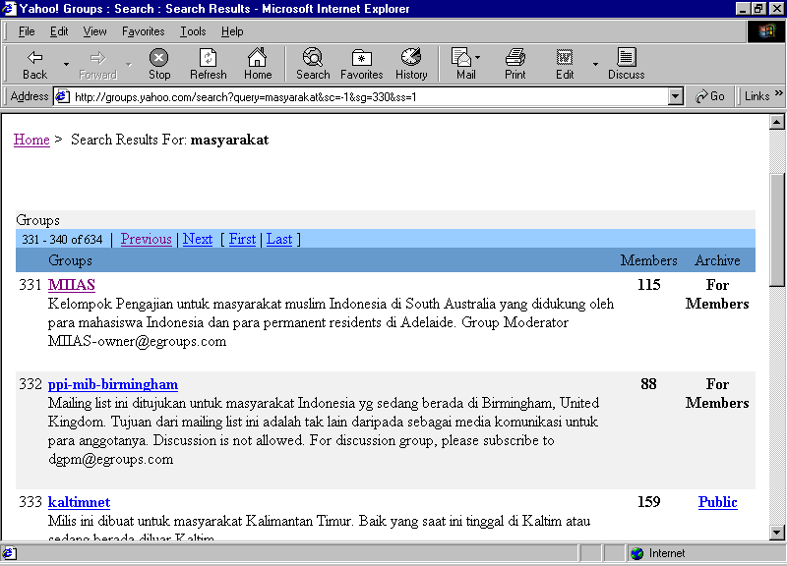
Right after the “search” button is pressed, http://groups.yahoo.com will provide us a list of mailing lists that contain this particular keyword. It shows the name of mailing list, description of the mailing list, number of subscriber, and type of mailing list (open or closed mailing list).

Since the number of mailing list is quite large, in the process, I choose only the one with more than one hundred subscribers will be thoroughly evaluated.
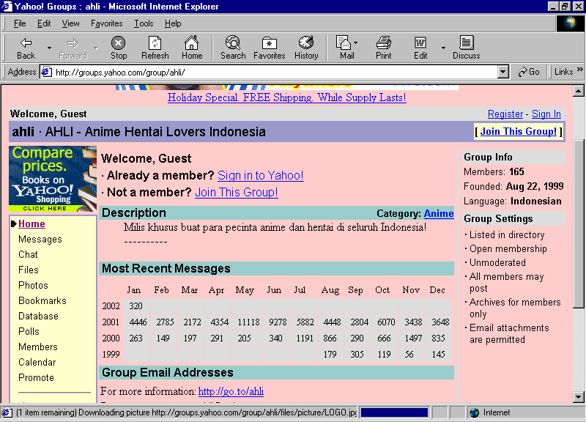
By clicking the name of the listed mailing list, we may find more information on particular mailing list, such as, total member, date the mailing list was found, language usage, archive of messages, monthly statistics of messages, as well as many administrative back office utilities to support the operation of the mailing lists.

Implicit Knowledge Exchange

In this section, we will examine the behavior of the community in exchanging their tacit / implicit knowledge. It can be probed through the way they interact on various Indonesian mailing lists on the Internet. Historically, in early ’90, some Indonesians started the first Indonesian mailing list at Indonesians@jamus.berkeley.edu. It gradually grows into many mailing lists.

In ’96, Institute of Technology Bandung (ITB) was putting two (2) Pentium servers on-line the Indonesian Internet community. It manages to serve more than 200+ mailing list. Currently, major Indonesian mailing lists can be found at

- http://www.yahoogroups.com also known as http://groups.yahoo.com may be the busiest mailing list server on the Internet, which serves 45.000+ Indonesian mailing lists. In this work, we will evaluate more closely the characteristics of mailing lists at http://groups.yahoo.com.
- http://groups.plasa.com runs by TelkomNet, the Indonesian Telkom ISP. As of mid February 2002, reported by Luqman El Hakiem Syamlan (luke@telkom.co.id) they serve 2299 Indonesian mailing lists.

Many of the information provided by http://groups.yahoo.com is quite useful in evaluating the characteristics of Indonesian communities on the Internet.

Number of Mailing Lists | 1278
Pornographic | 73 (5.7%)
Social Functions | 360 (28.2%)
Religious | 158 (12.4%)
Politics | 96 (7.5%)
Knowledge | 257 (20.1%)
Hobby | 110 (8.6%)
Business | 224 (17.6%)

In the end of the year 2001, I was evaluating http://groups.yahoo.com. I managed to see 30.000+ mailing lists out of 45.000+ mailing lists found. It was found that only 1278 mailing lists have more than 100 subscribers. It is interesting to note that most (28.2%) of the Indonesian cyber communities are using the mailing list mainly to say hello and other social functions. Next are the communities for getting knowledge (20.1%) and business activities (17.6%). The number of mailing lists on pornographic, religious, politics, and hobby are much less.

Total subscribers | 465,749
Pornographic | 59,871 (12.9%)
Social Functions | 89,372 (19.2%)
Religious | 56,035 (12.0%)
Politics | 32,388 (7.0%)
Knowledge | 83,648 (18.0%)
Hobby | 48,342 (10.4%)
Business | 96,093 (20,6%)

Subscriber distribution follows closely the distribution of mailing lists. Note that pornographic mailing lists seem to attract more subscribers. It is interesting to note that the number of total subscriber is only 450.000+ subscribers, far less than the four (4) million Indonesian Internet users as claimed by the Indonesian Internet Service Provider Association APJII http://www.apjii.or.id. Seems that most of Indonesian Internet users are still a beginners and use mainly web or occasional web / webmail, and not knowing how to interact or join the Indonesian mailing lists.

Message Distribution in 2001 | 1,635,395
Pornographic | 42,590 (2.6%)
Social Functions | 376,604 (23.0%)
Religious | 194,714 (11.9%)
Politics | 187,588 (11.5%)
Knowledge | 291,396 (17.8%)
Hobby | 236,023 (14.4%)
Business | 306,480 (18,7%)

The total messages generated in the year 2001 follows fairly similar pattern as the distribution of mailing lists. It is interesting to note that pornographic messages comprise only 2.6% of total messages.

Subscriber Activeness | Average Messages / Subscriber / Month
Pornographic | 0.71
Social Functions | 4.21
Religious | 3.47
Politics | 5.79
Knowledge | 3.48
Hobby | 4.88
Business | 3.20

The activeness of subscriber to interact can be measured as the average number of messages generated per subscriber per month. A surprising fact pop up, people in political communities seems to much talking with an average message close to six (6) messages per subscriber per month. Aot many subscribers like to listen to political debate. It may represent the typical political atmosphere in Indonesia. Hobbyists are next in the row on those who like to talk.

Interesting findings are found in political mailing lists, at least nine (9) mailing lists on Marxists and socialists. Some of the large mailing lists are sosialista (149 subscribers), pemudasosialis (75 subscribers), sosialisgroup (92 subscribers), and the largest is indo-marxist (618 subscribers). Their traffic is quite low on the average of 1-5 e-mail per month, shown the inactiveness of socialist’s ideology.

Partai Keadilan (PK) is identified as the most active Indonesian party that uses Internet as their main driving interaction media. Partai Keadilan is a relatively new party & managed to attract many young and students in Indonesia. Most of PK mailing lists are easily identified with pk in the first two characters on their mailing list name. Some of their large mailing lists are partai-keadilan (534 subscribers), PK_Linkbisnis (528 subscribers), pk-bandung (167 subscribers), pkjaksel (114 subscribers), pk-pesanggrahan (107 subscribers)., an d the largest is pk-info (1064 subscribers). Most of these mailing lists have quite modest traffic with 50-100 mail per month, only partai-keadilan has the highest traffic close to 1000 e-mail per month that really shows the activeness of Partai Keadilan as compared to the old-economy parties in Indonesia.

Total consumed bandwidth | 1,732 Kbps
Pornographic | 704 Kbps (40.7%)
Social Functions | 237 Kbps (13.7%)
Religious | 149 Kbps (8.6%)
Politics | 113 Kbps (6.6%)
Knowledge | 270 Kbps (15.6%)
Hobby | 103 Kbps (6.0%)
Business | 153 Kbps (8.8%)

Assuming an average 5Kbyte per message on normal mailing lists, and 30 Kbytes per message on pornographic mailing lists, it is found that the Indonesian mailing lists consume 1,7Mbps bandwidth with pornographic (40.7%) consumes most of the bandwidth. Bandwidth-wise, the normal traffic may actually subsidize those who download pictures from the Internet.

