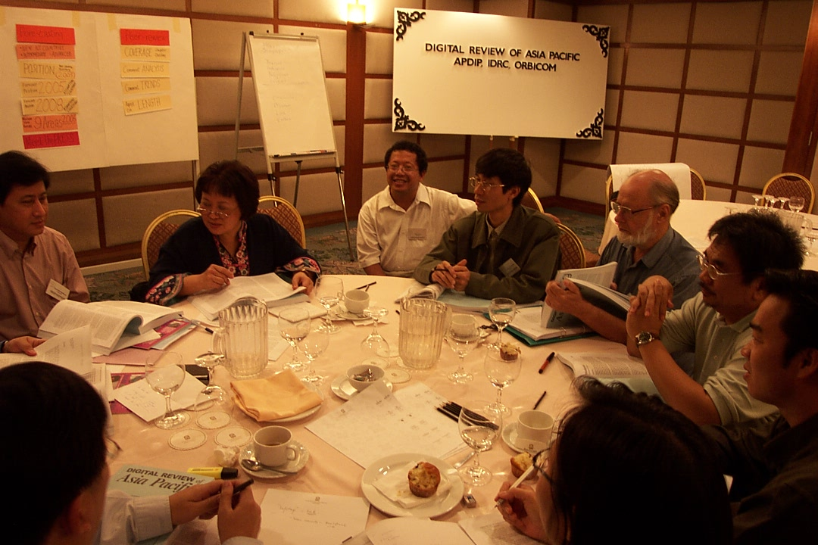

On 27-29 November 2002 in Kuala Lumpur, for the first time IT experts from 27+ Asia Pacific countries are gathering to review the status of ICT in the region. Onno W. Purbo is reviewing Indonesia ICT status.

