YOU CAN HELP
PREVENT CARD FRAUD

Since the late 1990s, merchants have been known to be targets of card fraud perpetrators who recruit staff to record magnetic stripe data of the credit cards used at the establishments. This is termed as “Skimming Counterfeit” and it is costing the financial institution astronomical fraud losses globally.

The equipment illustrated below are some data capture devices (“skimmers”) recovered in various criminal cases around the world. Each of these skimming devices can be used to copy and store data from the magnetic stripes of credit, debit, ATM and other cards. Please note that other models of these devices may also be in circulation.

DEFINITION OF SKIMMING
“The illegal copying (stealing) of the magnetic stripe data of a genuine card, including the encryption value, and subsequently transferring the data onto a counterfeit magnetic stripe for illegal usage.”

Skimming involved the solicitation of merchants’ owner and/or staff by the counterfeiting groups in stealing of the magnetic stripe data from a customer.
Most of these merchants identified for skimming activity are those that process the credit card ‘out-of-sight’ of the cardholder, i.e. restaurants, nightclubs, pubs, discotheques and hotel front offices, etc.

Most of the credit cards data are skimmed using these devices. Please take note that a skimmer on average is only 10 cm in length and can be easily concealed from view. To avoid detection, the perpetrators have also cleverly disguised these skimmers as a Y2K checker and pager (refer to exhibits B and D).

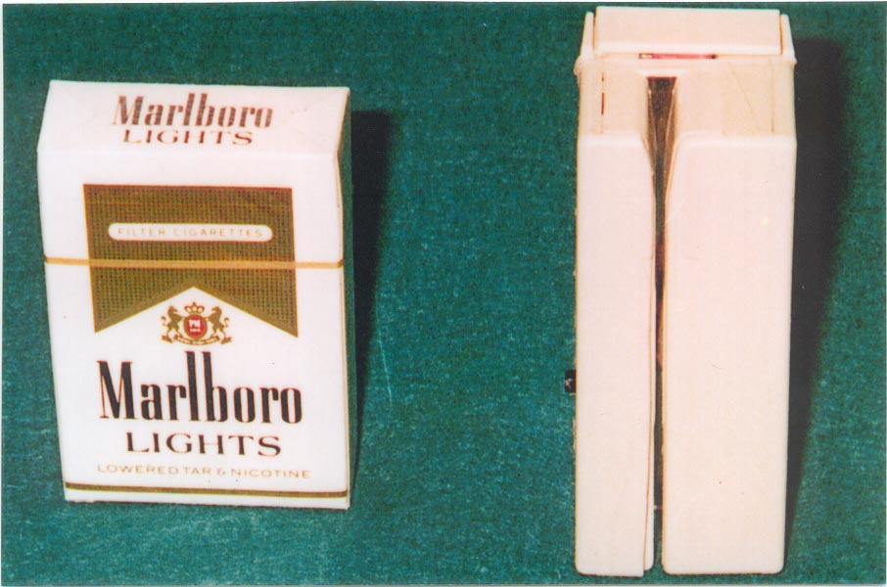 | 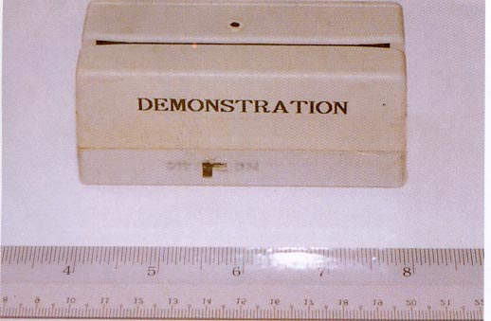
Exhibit A : Top View | Exhibit A : Front View
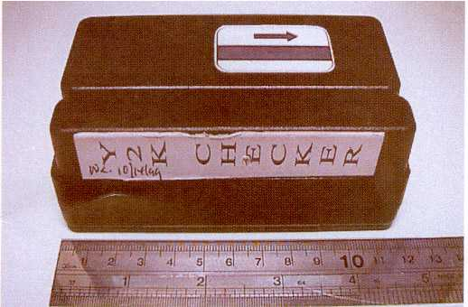 | 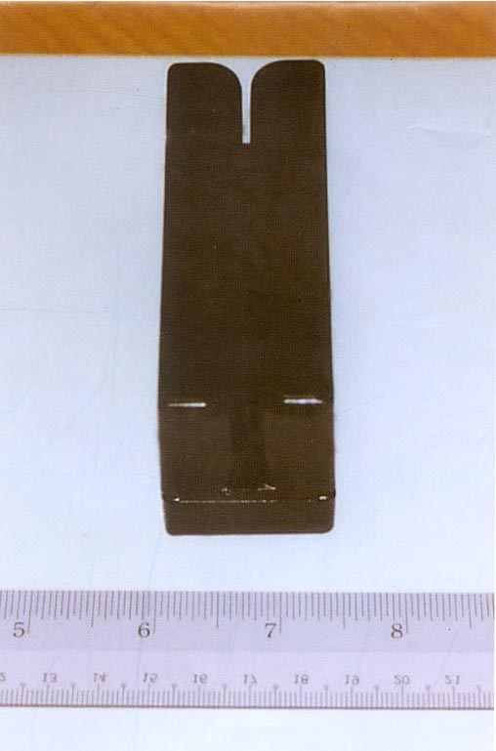
Exhibit B : Front View | Exhibit C : Top View
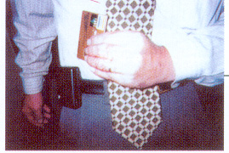 | 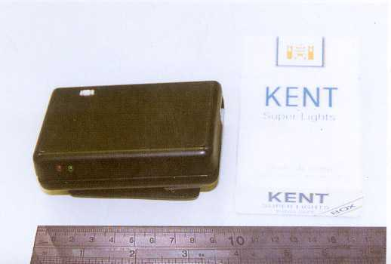
Exhibit D : On belt | Exhibit D : Side View

Modus Operandi:

When the cardholder presents the card for payment, the ‘collusive’ waiter/waitress swipes the credit card across a skimming device. This device basically reads and stores the magnetic stripe data. The physical card is then delivered to the cashier counter for normal processing of the card transaction. All this while, the cardholder does not know that his credit card magnetic stripe data has been compromised. The cardholder only knows about it upon notification by the Bank Fraud Prevention Unit or upon receipt of the monthly statement of account that will reflect a string of ‘disputed’ transactions.

To assist the bank to mitigate the risk of skimming, append below are guidance pointers for your reference.

- Treat your credit cards like cash.
- During check-in or out from a hotel, be aware on the movement of your credit card, and ensure that you note the staff swiping your card over a POS/EDC terminal only
- Beware and question the personnel handling your credit card when it is swiped in a device other then a POS/EDC terminal.
- Inform the Card Fraud Control Unit should you notice the personnel handling your card swipes it through a device similar to those reflected above.
- Do not allow anyone to take your card to another area to process your transaction.
- Speak to and recognize the waiter/waitress that handles your credit card during payment. This transmits a ‘deterrent’ message to the personnel handling the card who may have intention to ‘skim’ your credit card magnetic stripe data.

Should you come across any suspicious practices or noted similar-looking devices being applied at the merchant outlets, do contact our Card Fraud Control Unit or Authorisation Center immediately. Their contact numbers are appended below.

 | TELEPHONE HOTLINE
COUNTRY | FRAUD  CONTROL UNIT |  | 24-HRS  AUTHORISATION CENTER
 | Office | Hand-phone
Hong Kong | 2282 1118 | 909 92326 | 2282 1115
Taiwan | 2715 9087 | 920 782154 | 271 56100
Malaysia | 7720 4620 | 012 7032828 | 772 04611
Singapore | 780 7666 | 973 72966 | 780 7629
Philippines | 830 1231 | 091 78381026 | 830 1222
Thailand | 232 6549 | 01 8355569 | 636 1144/5
India | (80) 532 1392 | 984 5044005 | (80) 558 6600
Indonesia | 5739618 x2830 | 08 11991195 | 573 9618 x2820/28/27
Brunei | 223 4401 | N/A | (65) 780 7629
Grindlay | (44) 8219 535 | 984 1026942 | (44) 821 2255
SCB Manhattan | 265 53682 | N/A | 265 53128

